00_Materials
Monday, July 29, 2024
8:01 AM

- GeekForGeeks :- https://www.geeksforgeeks.org/cpp-interview-questions/
- GeekForGeeks(Coding Questions):- https://www.geeksforgeeks.org/cpp-coding-interview-questions-and-answers
- InterviewBit :-https://www.interviewbit.com/cpp-interview-questions/#difference-between-c-and-c++

C++ New Features :- https://github.com/AnthonyCalandra/modern-cpp-features?tab=readme-ov-file

CPP Nuts Playlist :
https://www.youtube.com/watch?v=QSuBwGmFQqA&list=PLk6CEY9XxSIDy8qVHZV-Nf-r9f2BkRZ6p

Practical Polymorphism C++

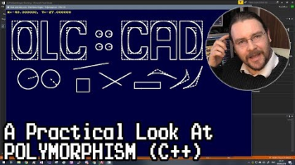

TO DO(C++)
Tuesday, October 8, 2024
10:16 AM
  - Learn C++ vectors and its operations
  - Ordered Set vs Unordered Set in C++

TO REVISE
01_CopyConstructor_vs_DeepConstructor
06_Move_Semantics
19_Static_Cast
20_Dynamic_Cast
21_Reinterpret_Cast
22_Const_cast

C++ Coding Interview Brush-Up Checklist
Tuesday, April 22, 2025
9:10 AM
Lambda Expression
Create a function having multiple return types using lambda
Casting
Static_Cast
Reinterpret_cast
Const_cast
Function Pointers
Callback Function using Function pointers
Implementing Statemachine using function pointers
Practical Example of statemachine
String
Reverse a String
Ascii to string conversion
String to Ascii conversion
Create a custom String Class
LINKED LIST
Insert a nod in the Middle
Find Mid Node
Reverse a Linked List
Check for for loop
Merge 2 linked list
Sort a linked list
Circular Linked List
Doubly Linked List
STACK
Stack using Linked List
Bracket Matching
QUEUE
Queue using Linked List
Queue using Stack
Circular Queue
Doubled ended Queue (Dequeu)
BIT MANIPULATION
Integer as array of bits
Convert Binary to Decimal
Ones and Twos Compliment
Convert Decimal to Binary
Square a number with Addition
Addition using Bitwise operation
Count Ones and Zeros
Bitpacking_using_Bitwise_Operator
Bitpack using structures with explciit packing
Bit pack using structure without explicit packing

SORTING
Iterative_Merge Sort
Recursive_Merge Sort
Insertion Sort
Quick Sort

DESIGN PATTERNS
Singleton Pattern
Factory Pattern
Burger Joint Example
Observer pattern

Emerson
Tuesday, July 29, 2025
8:02 PM

6. Coding Problems:
  - Basic Algorithms: Fibonacci sequence, Greatest Common Divisor (GCD), finding common elements in sorted arrays.
  - Data Structure Implementations: Implementing a simple task scheduler using a priority queue.
  - String Manipulation: Reversing a string, finding substrings.
  - Array Problems: Finding duplicates, sorting, searching.

From <https://www.google.com/search?q=Emersion+C%2B%2B+coding+questions&rlz=1C1GCEA_enSG1126SG1126&oq=Emersion+C%2B%2B+coding+questions&gs_lcrp=EgZjaHJvbWUyBggAEEUYOdIBCjEwNzY4ajBqMTWoAgCwAgA&sourceid=chrome&ie=UTF-8>

1. Arrays & Strings
  - Rotate array (left/right) – [Cyclic rotation]
  - Kadane’s Algorithm – Maximum subarray sum
  - Sliding window problems – Max sum subarray of size K
  - Two sum, Triplet sum = 0, Move zeros to end
  - String reversal, Anagram check, Palindrome substrings
  - Remove duplicates in-place from sorted array
2. Linked List
  - Reverse a linked list (iterative/recursive)
  - Detect cycle in a linked list (Floyd’s algo)
  - Merge two sorted linked lists
  - Find middle node / kth node from end
  - Remove nth node from end
3. Stack & Queue
  - Next Greater Element
  - Valid Parentheses
  - Min Stack implementation
  - Queue using stacks
  - Circular Queue / Ring Buffer
4. Trees (Basic Only)
  - Inorder / Preorder / Postorder traversal (recursive + iterative)
  - Height of binary tree
  - Check if binary tree is balanced
  - Lowest Common Ancestor (LCA)
  - Mirror / Symmetric tree
5. Recursion & Backtracking
  - Factorial, Fibonacci (with memoization)
  - N-Queens problem (just overview)
  - Subset / Power set generation
  - Permutations of a string or array
6. Sorting & Searching
  - Quick Sort / Merge Sort (basics only)
  - Binary Search on sorted array
  - Binary Search variations (first/last occurrence)
7. Bit Manipulation
  - Check if a number is power of 2
  - Count set bits
  - XOR properties (find missing number or single number)
8. C++ STL Knowledge
  - Use of std::vector, std::map, std::set, std::stack, std::queue
  - Lambda functions (e.g., for custom sort)
  - Smart pointers (unique_ptr, shared_ptr basics)
  - Difference between map and unordered_map
  - Iterators and range-based loops
9. OOP + C++ Concepts
  - Inheritance, Polymorphism (virtual functions)
  - Constructor types
  - Rule of 3/5
  - Deep vs shallow copy
  - RAII, smart pointers
  - Mutex, lock_guard (basics – just understanding)

C++ - 11 Features
Tuesday, July 30, 2024
3:26 PM

C++14 Features
Tuesday, April 22, 2025
7:20 AM

C++17 Features
Thursday, May 15, 2025
10:38 AM

i. Structured Binding
Thursday, May 15, 2025
10:39 AM
  - Structure binding helps to unpack tuple,pair,array or struct into individual variables in a single line.
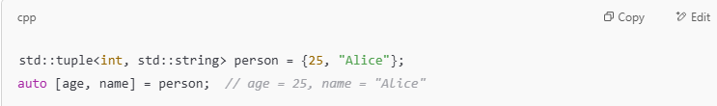
  - This Feature allows easy access of elements from STL container.

ii.std::optional
Thursday, May 15, 2025
10:35 AM
  - Std::optional<T> is a wrapper that may or may not contain a value of type T
  - It helps to avoid undefined behavior when function does'nt return a value.
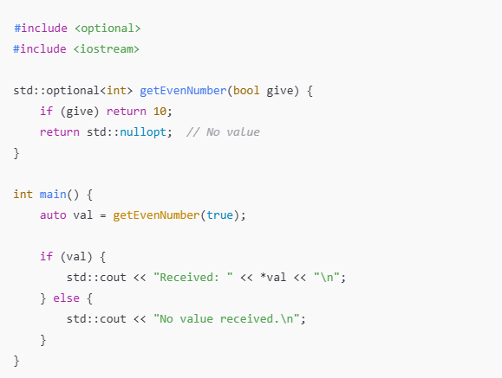

  - Safer than pointers for representing missing data.
  - Avoids the need for exceptions or special return values.
  - Works well with functions that may or may not succeed.
  - Helps write more robust and readable APIs.

iii. if constexpr
Thursday, May 15, 2025
11:11 AM
- Allows the compiler to include or discard a code branch based on template parameters. This helps to avoid compilation errors from invalid or ill-formed code.
- if vs if constexpr
  - if is a runtime check :- Both branches must compiler,even if one never runs
  - if constexpr is a compile-time check :- only the chosen branch will be compiled.
💡 Example: Type-Specific Behavior
🔴 Without if constexpr (problematic)
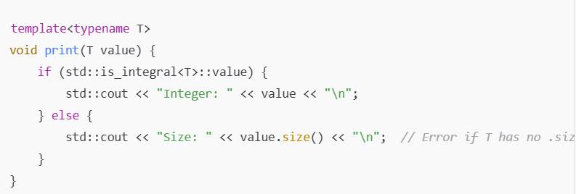

- This will fail to compile if T is int, even though the .size() line would never run for an integer.

✅ With if constexpr (safe)
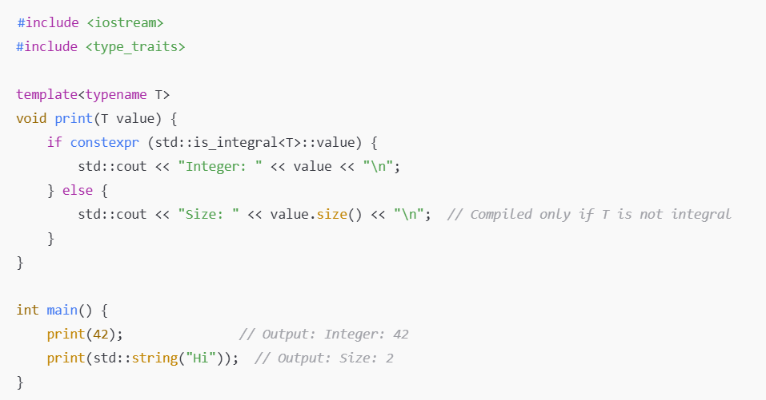

iv. std::string_view
Thursday, May 15, 2025
11:21 AM
- std::string_view is a non-owning reference to a string .
- It avoids unnecessary string copying ,improving performance in read-only scenario.
🔍 Why not just use std::string?
- When we pass a std::string to a function ,it will copy the whole string(unless passed by reference).
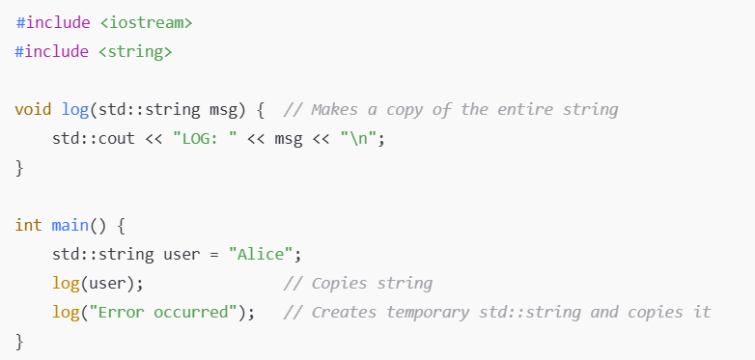
⚠️ Disadvantage: Copies data every time, even if you're just reading it.

✅ Using std::string_view (no copy)
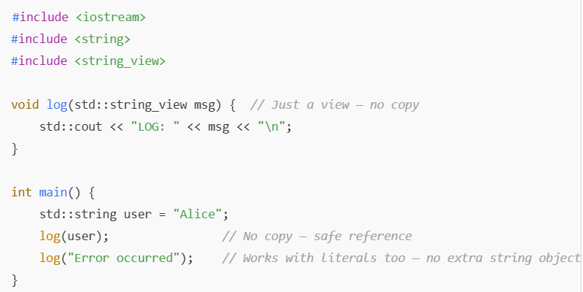

v.Filesystem Library (<filesystem>)
Thursday, May 15, 2025
2:14 PM
  - This library allows to perform file system operations in a portable and safe way .
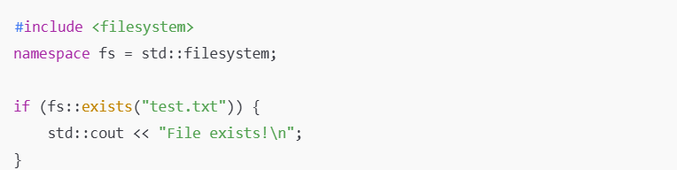

C++20 Features
Friday, July 11, 2025
8:20 PM

01_Span
Friday, July 11, 2025
8:20 PM
- Span is a C++20 feature,which provides a non-owning view over a contiguos sequence of elements like arrays,vectors or C-style arrays
✅ Key Features:
- Non-owning: It doesn't manage memory, just observes it.
- Safe alternative to raw pointers.
- Bounds-checked in debug builds.
- Supports slicing (subviews).
- Can be passed to functions instead of raw arrays or std::vector<T>&.
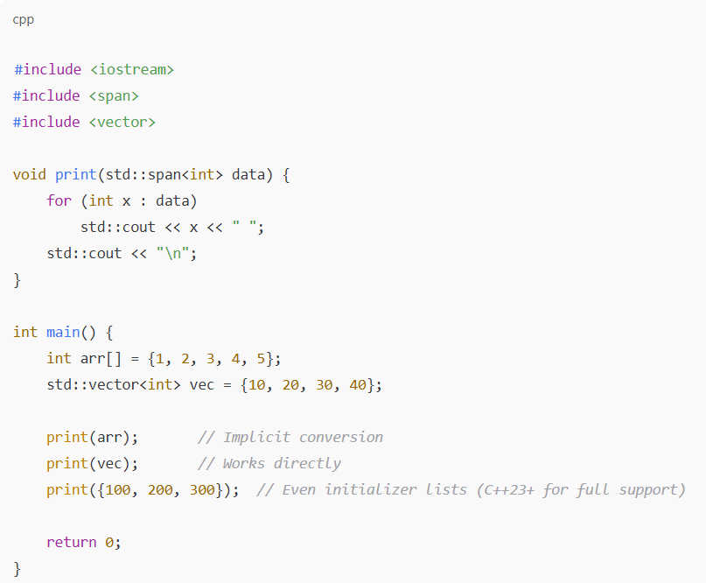

🔍 Use Cases:
- Pass subarrays without copying
- Replace T* data, size_t len style APIs
- Avoid lifetime issues with raw pointers
- Easily slice or view a subset of a buffer
🧠 Why use std::span?
Without Span | With std::span
void f(int* data, size_t n) | void f(std::span<int> data)
Need manual size tracking | Size is part of the span
Easy to misuse | Safer, clear intent
📦 How is size part of std::span?
std::span<T> internally stores:
- A pointer to the beginning of the data
- The number of elements (the size)
So, it's like a combination of:
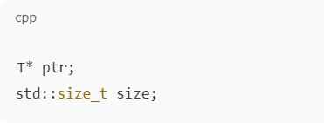
🔍 So when you create a std::span like this:
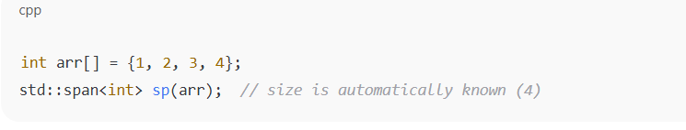
✅ The span knows:
- Where the data starts (pointer to arr[0])
- How many elements there are (4)

01_CopyConstructor_vs_DeepConstructor
Friday, August 2, 2024
10:10 AM
  - Copy Constructor
  - Copy constructor creates a new object as a copy of an existing object .
  - Copy constructor performs a shallow copy .
Shallow copy :-It copies the value of data members ,pointers but not the actual memory
pointed by the pointers.
=>Shallow copy can lead to issues such as dangling pointer since multiple objects point to same memory area

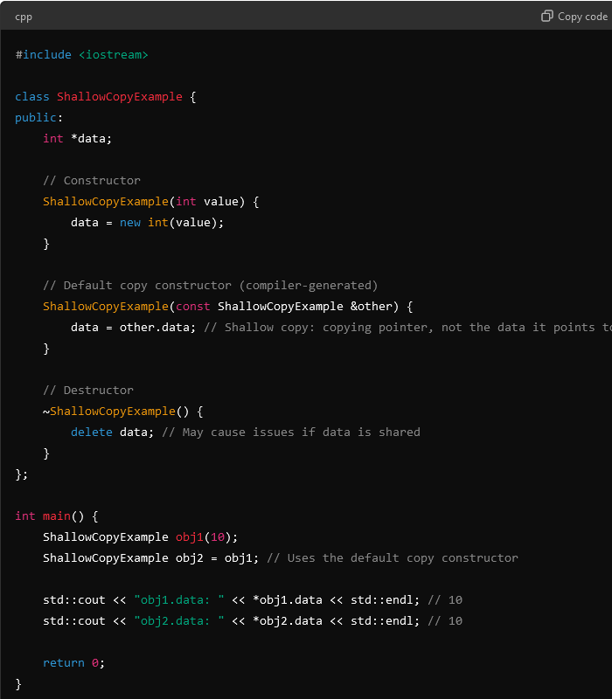

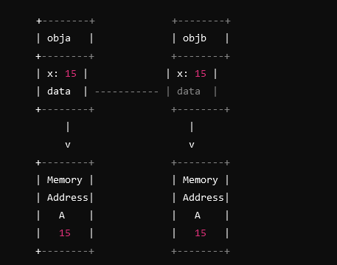
ISSUES
  - Both obj1 and obj2 share the same memory location for data.
  - When destructor is being called for one object ,it deletes the shared memory .The other object will then be left with a dangling pointer,leading to undefined behaviour.
  - DEEPCOPY CONSTRUCTOR
  - Deep Copy :- Allocates new memory to the copied object and copies the actual data
  - Deep copy constructor creates a new object and allocates new memory to its data members,copying the actual content rather than pointers
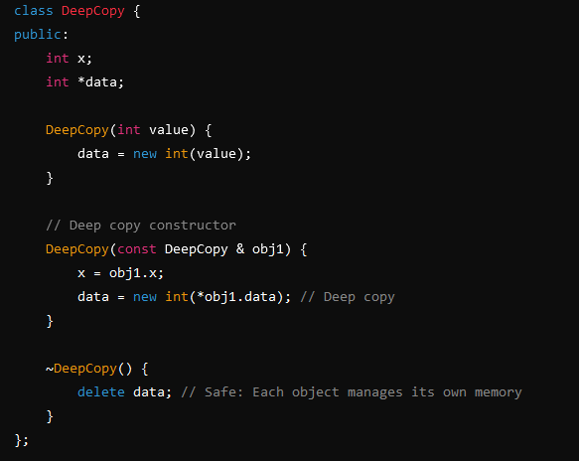
  - In deep copy constructor, a new memory location is made and data is copied from the source object to its new memory location.In this way object manages its own memory and do not interfere with each
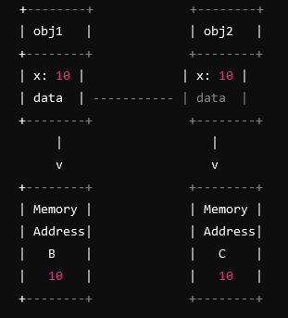

02_CPP_Friend_Function
Wednesday, August 7, 2024
8:47 AM
- Friend function in C++ is a function that is not a member of a class but can access the private and protected members of the class
USECASE :- Friend functions are used when an external function needs to access class members that are otherwise inaccessible using regular public methods .

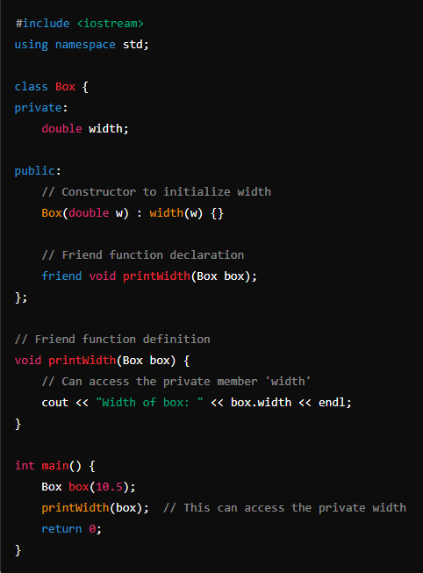

Features of friend function
- Friend functions are not member functions :- They are defined outside the class but can access its private and protected members
- Friend function can be used across multiple classes :- A single friend function can be made as friend of multiple classes
- Friendship is not inherited:- If a base class grants friendship to a function ,the derived class don’t automatically inherit that friendship

03_Public_Private_Protected Members
Sunday, September 1, 2024
1:32 PM
- Public Members
- Public members can be accessed and modified outside the class
- Public members can be accessed by the derived classes and its objects
- 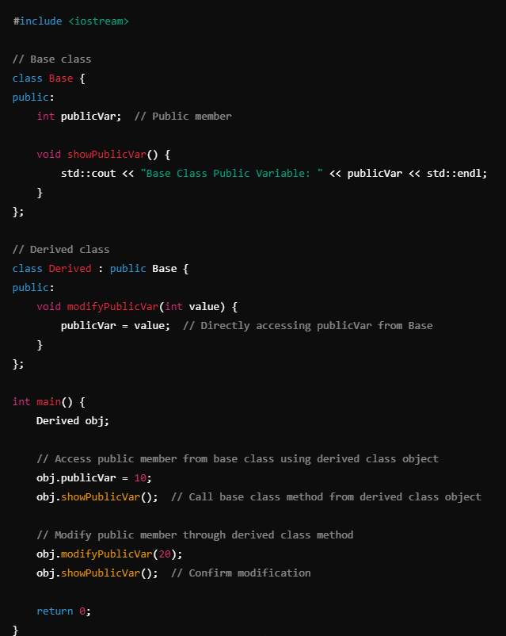
- In case of Inheritance,public members of the base class are inherited as public members of the derived class .Making it accessible from both outside the class and within the derived class.
- Private Members
- Private members in C++ are restricted to the class in which they are declared.They cannot be accessed diirectly from the outside class ,not even by derived class
- We need to use setters and getters to indirectly access these private members .

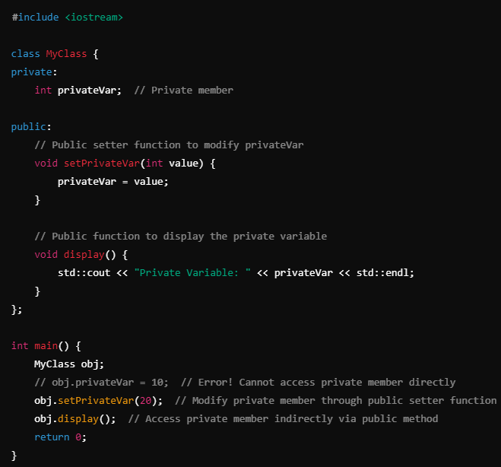
iii. Protected Members
- Similar to private members ,protected members cannot be accessed directly from outside the class(through objects) but unlike private members protected member can be accessed by the derived classes
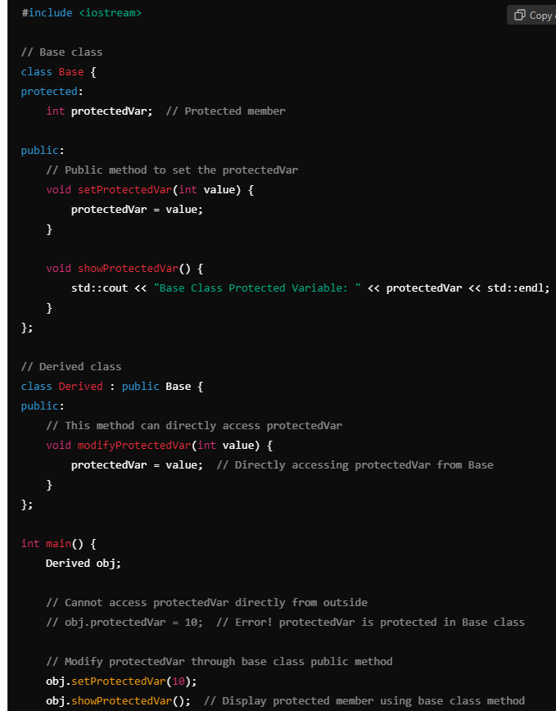

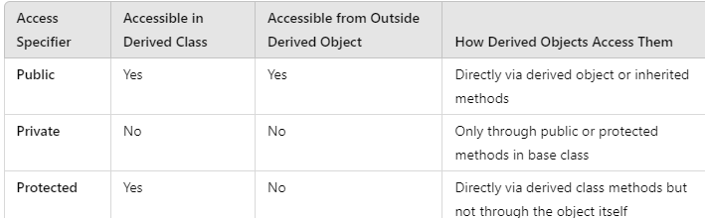

04_Public_Private_and_Protected_Inheritance
Friday, October 4, 2024
9:06 PM

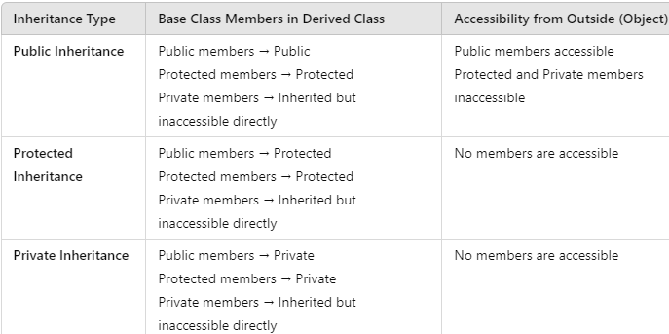

INHERITANCE TABLE
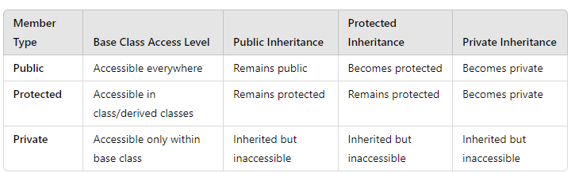

05_lvalue vs rvalue reference
Wednesday, October 9, 2024
8:24 PM
  - Lvalue reference :
    - An lvalue reference refers to a named object that has fixed address in memory.
    - Ivalue reference can be used to modify the value of object it references
      - int x = 10; (Here, x is an lvalue.)
      - int& y = x; (Here, y is an lvalue reference to x.)
      - y = 20; (Modifies the value of x through y.)

  - Rvalue reference
    - An rvalue reference refers to a temporary object that does'nt have a fixed address in memory.It cannot be used to modify the value of object it references
      - int x = 10; (Here, x is an lvalue.)
      - int&& z = x + 5; (Here, z is an rvalue reference to the temporary result of x + 5.)
      - z = 20; (This is invalid because z cannot be modified.)

06_Move Semantics
Monday, September 2, 2024
3:17 PM
  - Move semantics in C++ is a feature to improve performance by allowing the resources of an object to be moved rather than copied .
    - This is very useful when dealing with expensive resources like dynamic memory,file handles or network connections ,where copying can be costly in terms of time and memory .
  - Move semantics avoid unnecessary deep copies,leading to performance gain in the program that manages expensive resources .
KEY CONCEPTS
  - Rvalue Reference(&&)
    - An rvalue reference is a reference that can bind to a temporary object.It allows us to modify the temporary objects instead of creating a copy of it
  - Move Constructor
    - Move constructor takes an rvalue reference as a parameter and transfers ownership of the resources from the source object to the destination object,leaving source in a valid but unspecified state .

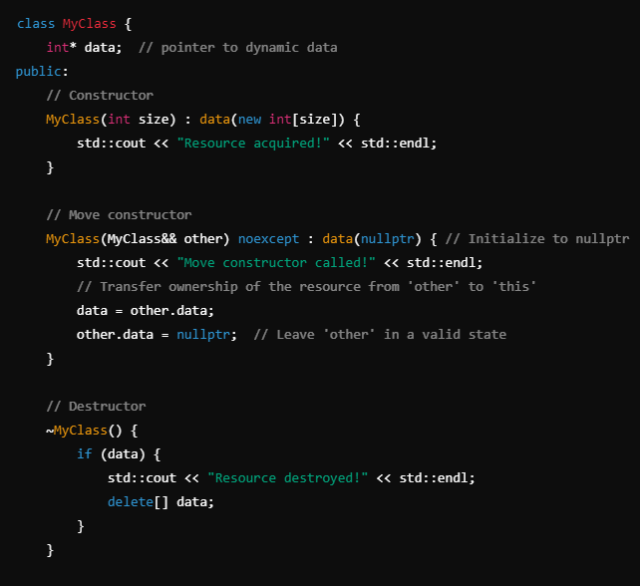

  - Move Assignment Operator
    - The move assignment operator transfer ownership of resources from one object to
Other,leaving source in a valid but unspecified state.

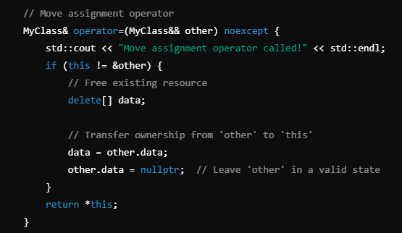
  - std::move
    - std::move is an utility function that casts an lvalue to an rvalue reference ,allowing it to be moved rather than copied.It's used when we want to move an object explicitly instead of copying
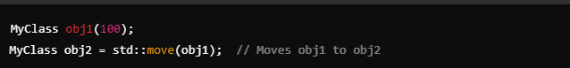
  - obj1 is an lvalue reference (having an address)
  - During std::move(obj1);it becomes an rvalue reference and ownership is transfered

07_Friend_Classes_vs_Friend_Functions
Tuesday, September 10, 2024
6:50 AM

1.Friend Function
- Friend function is a standalone function that has access to private and protected members of a class.
- Friend function is declared inside the class using friend keyword but defined outside the class
- Friend function is not a member of a class but can access the private and protected data.
- Friend function can be a global function or a member of another class.
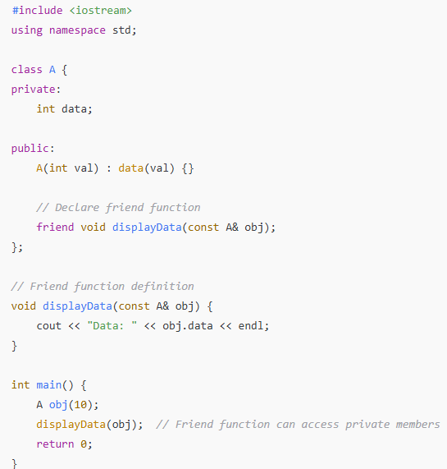
When to use Friend Function ?
- When we need an external function to operate on private/protected data of a class
- When we want to define operator overloading for non-member functions like operator<< or operator +
2.Friend Class
- Friend class is allowed to access the private and protected members of the class that declared it as a friend — through any of its member functions.
- The entire class gets access to the private/protected members
- Its used when 2 classes need tight coupling

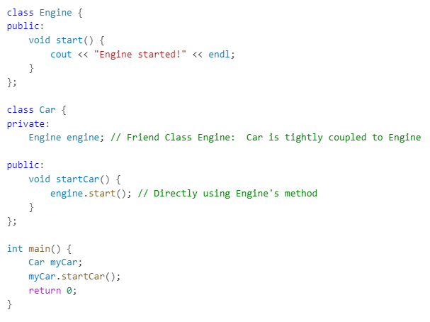
Tight Coupling :- Here the Car class directly depends on Engine.If Engine changes ,Car also changes .

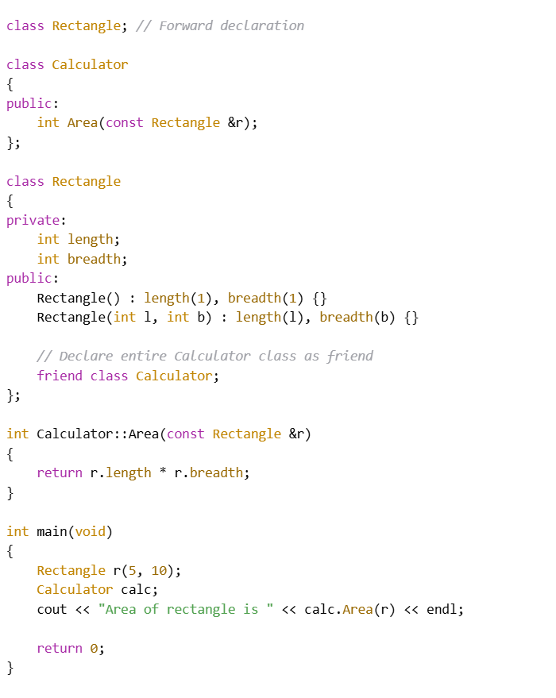

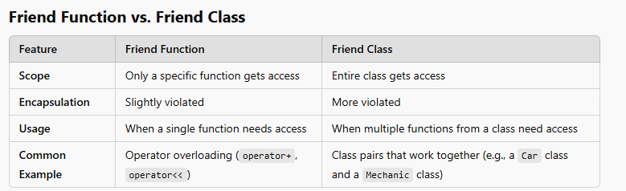

08_Non_Static_Nested_Classes_vs_Static_Nested_Classes_in_CPP
Tuesday, September 10, 2024
7:12 AM

📘 Nested Classes in C++
✅ Definition:
A nested class in C++ is a class defined inside another class.
C++ allows a class to be declared as a member of another class, called a nested class.

🧠 Key Points:
- ✅ Nested classes are conceptually static
  - They do not have access to non-static members of the outer class.
  - They do not require an object of the outer class to be created.
- 🔐 Access control (private, protected, public) applies:
  - Nested class can be public, protected, or private inside the outer class.
  - The outer class does not automatically have access to the nested class's private members.
- 📦 Nested classes are useful for logically grouping helper or tightly coupled classes.

🔧 Example 1: Basic Nested Class
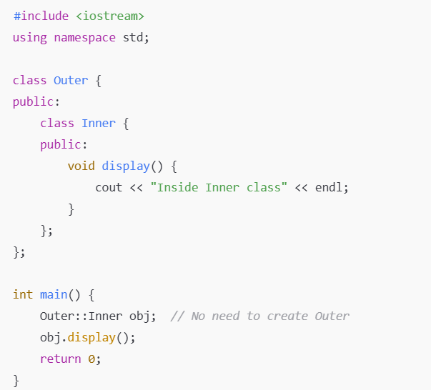

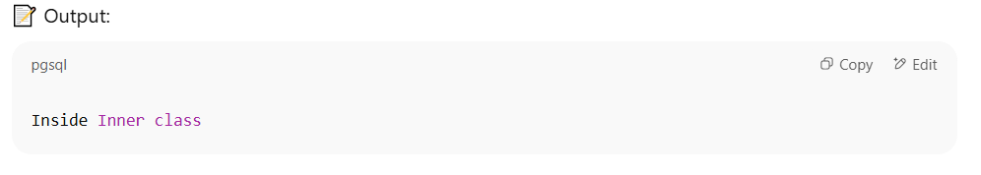
🔧 Example 2: Access Outer Class (simulated non-static)

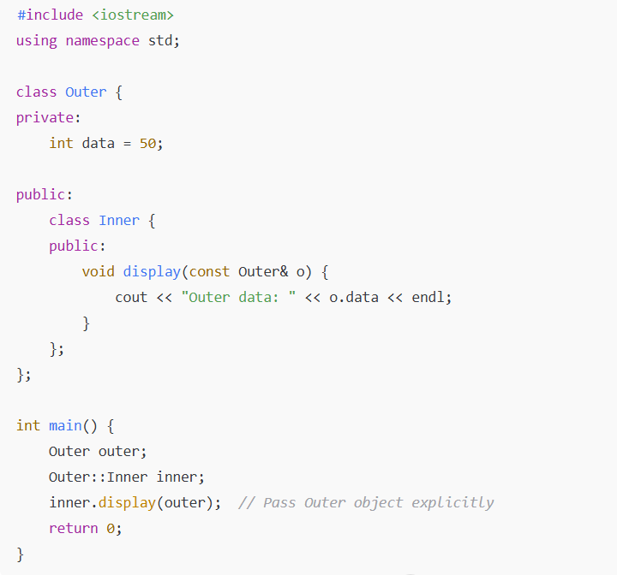

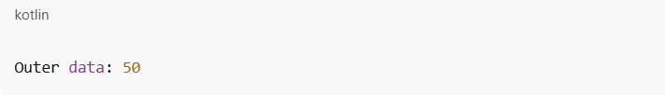
🔧 Example 3: Nested Class with Static Members
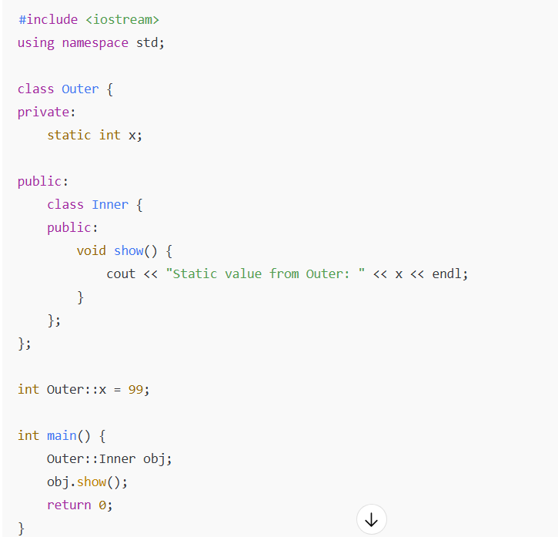

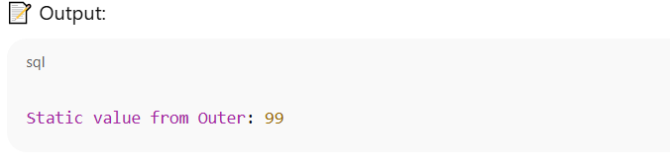

09_Static_Members_& Static_Functions_in_CPP
Tuesday, September 10, 2024
7:23 AM
1.STATIC MEMBERS in C++
- Static members(both variables and functions )belong to the class rather than any specific objects.They are shared among instances of the class.
i.Static Member Variables
- Declared using static keyword inside the class.
- Only one copy of static variables exist and are shared among all objects
- Static variables must be defined outside the class
- Static members can be accesed using either an object or class name(ClassName::variable).
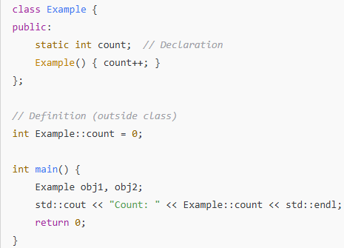

2.STATIC MEMBER FUNCTIONS
- Static Member Functions can access only static members(static variables or other static functions).
- Cannot access non-static members ?(Static functions does'nt belong to any specific instances).
- Static functions can be called using class name ClassName::function().
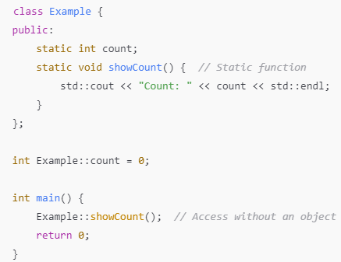
KEYPOINTS
✔ Static variables persist throughout the program.
✔ Static functions don’t require an object to be called.
✔ Used for utility functions and class-wide data management

10_Const_vs_ConstExpr
Monday, October 7, 2024
4:55 PM
  - Const
    - Used to declare a constant value that cannot be modified after initialization .
    - Can be used with variables,pointers,references and member functions.
    - The value is determined at runtime,does'nt necessarily have to be known at compile- time.
  - Constexpr
    - Used to declare values that are constant expressions. i.e values that can be evaluated at compile time .
    - Constexpr can be used for varaiables,functions and even lambdas.But the functions or values must be evaluated at compile-time.
So, use const for values that are constant but evaluated at runtime, and use constexpr when the value must be available at compile-time for further optimization.

11 Initializer list in C++
Wednesday, January 1, 2025
8:57 AM

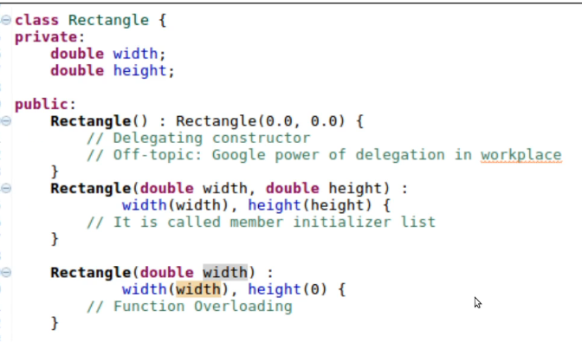
- It’s the recommended way of initializing constructors in C++
- The values of data members are assigned even before start of constructor
- It’s the only way to initialize const member data and references
- Const datamembers and references are to be created at the point of creation (initialization phase of the constructor and not the body)
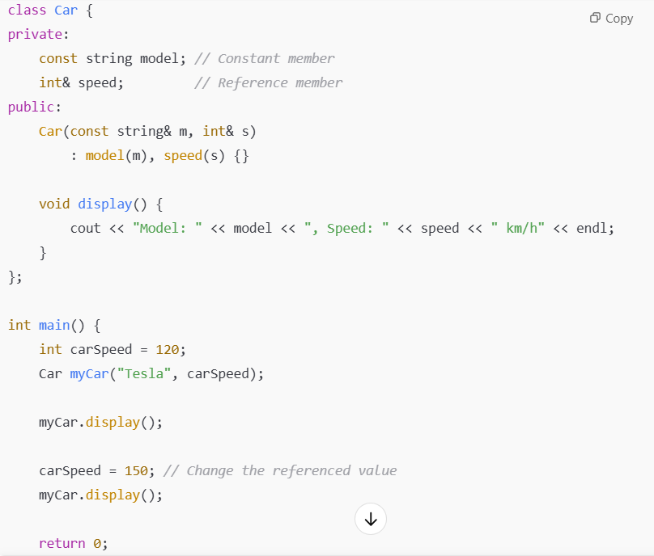

12 Encapsulation & Abstraction
Wednesday, January 1, 2025
7:37 AM
ENCAPSULATION
- It means to encapsulate(make a capsule of) all datamembers & member functions within a single capsule
- Struct & classes allows encapsulation
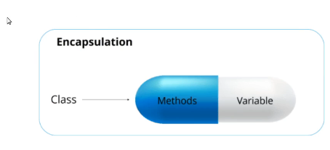
ABSTRACTION

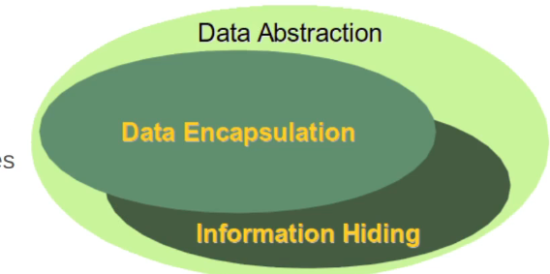
- Abstraction is about hiding unwanted details while showing only most essential things in a given context
  - Hide datamembers and member functions as much as possible and reveal only relevant functionality to the end user
  - Separate(hide) Implementation (How) from interface(what)
    - Later there could be several implementations(Many Hows)

13 Abstraction in C++
Wednesday, January 1, 2025
8:32 AM
- Public/private access modifiers to reveal/hide details(data & functions)
- ::scope resolution operator to separate implementation from interface
- Header files to separate the written code and source file that has the implementation .
- Levels of Abstraction
  - Higher the level,lesser the details
  - Lower the level ,higher the details
  - Whole system is the highest abstraction(e.g Google search engine)
  - Designed by Inheritance
  - Utilized by polymorphism
ABSTRACTION DERIVED BY INHERITANCE UTILIZED BY POLYMORPHISM
🔍 1. Abstraction — "Designed by Inheritance"
Abstraction means hiding implementation details and showing only the essential features of an object.
In C++, we achieve this using:
- Abstract base classes (interfaces)
- Pure virtual functions
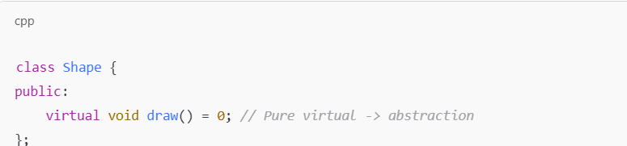
This design sets up a contract/interface without telling how draw() is implemented.
✅ Inheritance lets derived classes implement this interface:
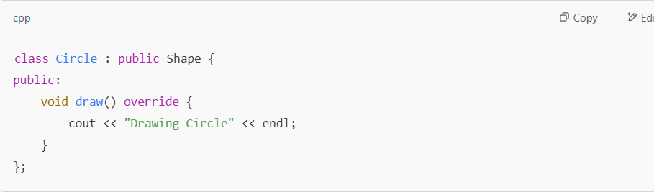
So, inheritance is how abstraction is designed/structured.

🔁 2. "Utilized by Polymorphism"
Once you have an abstract interface (Shape), and concrete classes (Circle, Rectangle, etc.), polymorphism allows:
- Using a base pointer/reference to refer to derived objects
- Calling the correct overridden function at runtime
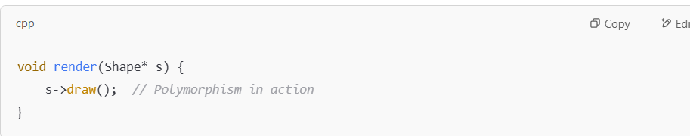
Here:
- We use abstraction (the Shape interface)
- Through polymorphism, the correct draw() is called at runtime

14.Copy Elision in C++
Thursday, January 30, 2025
4:33 PM
  - Copy elision is a compiler optimization that allows to skip over a call to the copy constructor.

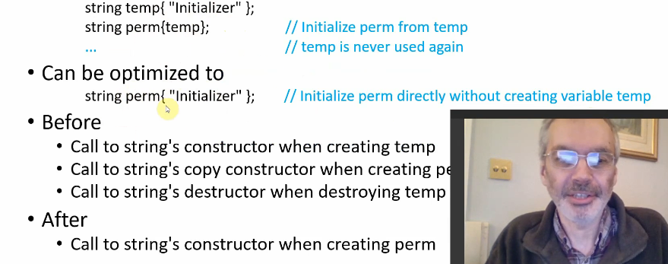

15.Default and Delete Member Function in C++
Thursday, January 30, 2025
7:18 PM

  - = default (Defaulted Member Function )
  - Default keyword tells the compiler to generate the default implementation of a special member function
  - Default specifier is used when you want the compiler generated behavior and you want to explicitely specify it
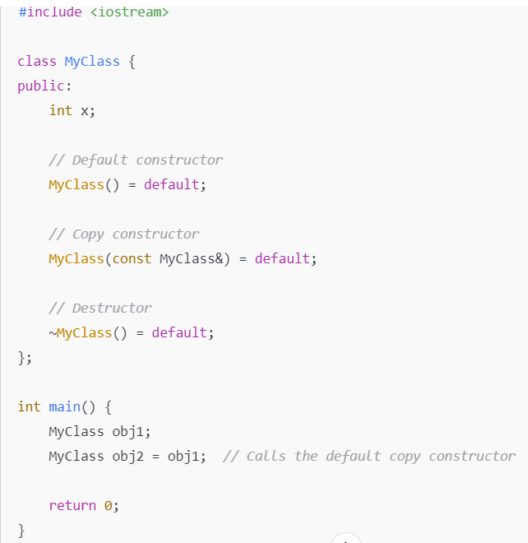
  - =delete(Deleted Member Functions)
  - Delete specifier prevents the compiler from generating a function and make it unusable .
  - Used for disabling a function e.g preventing copy or move operation
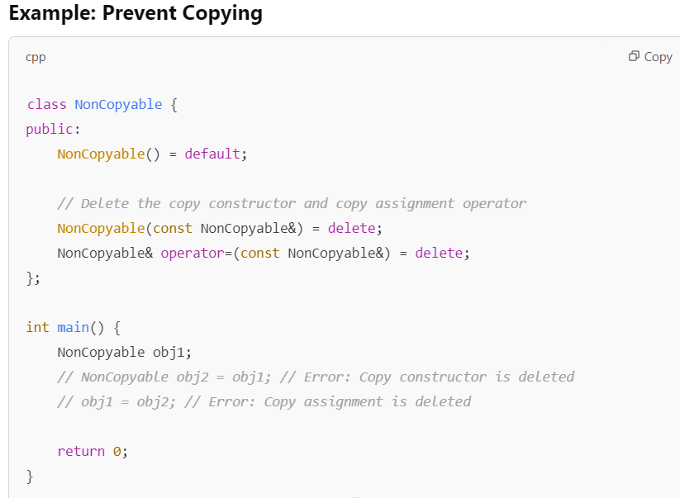

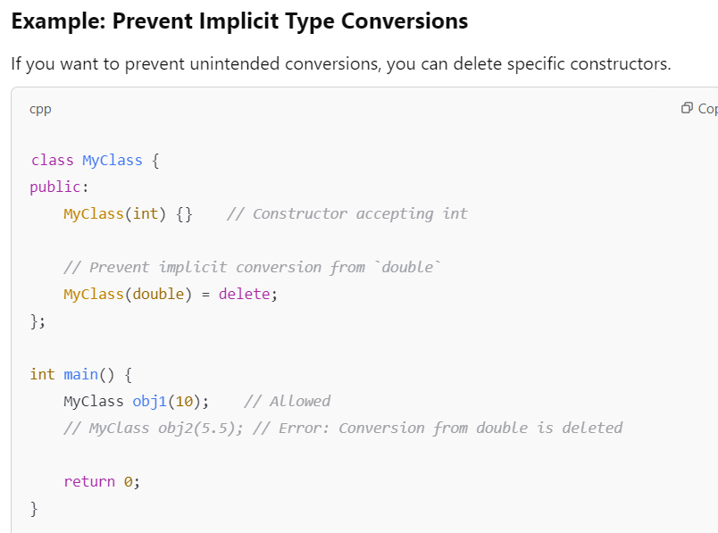

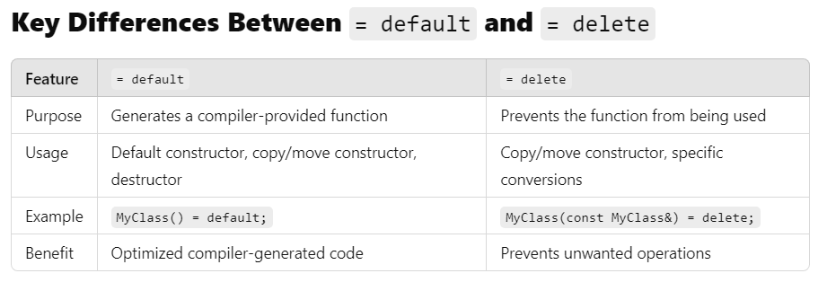

16.Functors in C++
Tuesday, February 4, 2025
7:09 PM
- Functors are also called as function object,an object of a class that can be called like a function .
- This is achieved by overloading the function call operator ().

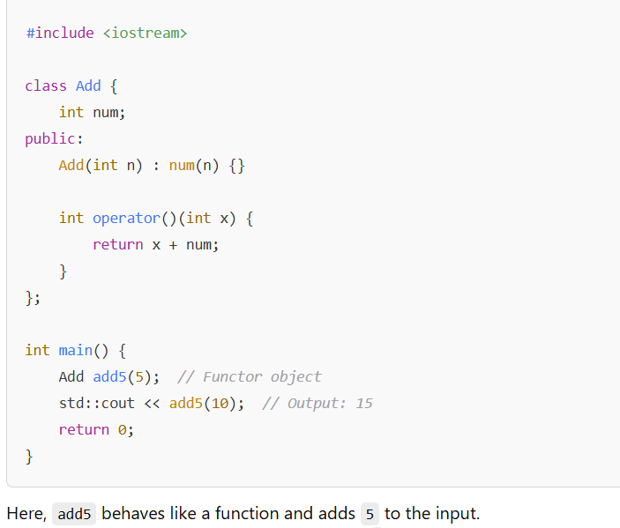
Advantages of Functors
- Stateful -> Unlike regular functions,functors can maintain state through member variables .
- Reusable & Modular:- They can be used as argument to STL alogorithms like std::sort.
- More efficient than function pointers :- Since they can be inlined by compilers ,they often have better performance than function pointers.

17.Static Variables C vs C++
Friday, February 7, 2025
1:34 PM
  - Static variables at File scope (Global static)
    - In C ,static keyword at file scope makes the variable internal linkage.i.e the variable is visible only within that specific source file
    - 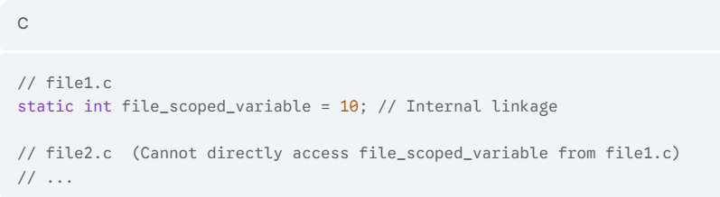
    - In c++ ,static at file scope gives same internal linkage.However in c++ namespaces are used to provide more structured way to control visibility.
    - Unnamed namespaces achieve same effect as static in c
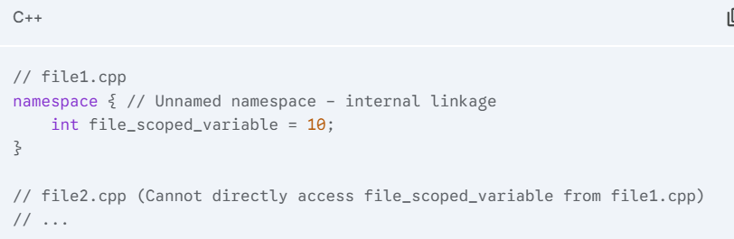
Nb: same for static functions also
  - Static Member variables in classes(C++ feature)
    - In c++, a static member variable belongs to the class itself and not to the individual object of the class.
    - There is only one instance of the static member,shared by all object

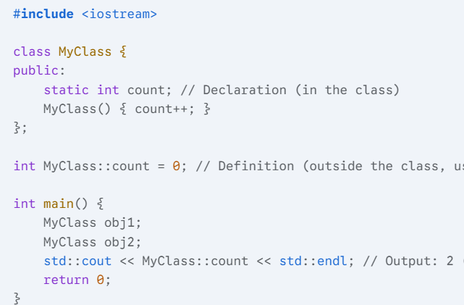
  - Changes to count through any object is reflected across all object of the class

18.Static type vs dynamic type in c++
Thursday, February 13, 2025
3:09 PM

1.Static Typing (Compile-Time Typing)
- The type of variable is known and checked at compile time .
- Compiler enforces type correctness,prevents type related errors before execution .
- Improves performance since type checks are resolved at compile time
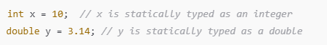
ADVANTAGES
- Faster execution (no runtime type checks).
- Detects type errors at compile-time.
- Better optimization by the compiler
2.Dynamic Typing(Run-Time typing)
- Type information is determined at runtime rather than compile time .
- Typically used with polymorphism and void* pointers or dynamic types like std::any
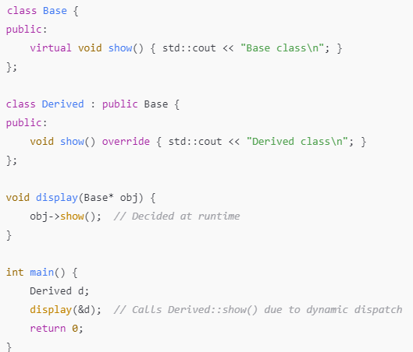
How Type is Determined Dynamically
- The function show() is marked as virtual in the Base class.
- When calling obj->show(); inside display(), the actual function to be called is determined at runtime based on the object's dynamic type.
- The compiler generates a Virtual Table (vtable), which stores function pointers for virtual functions.
- At runtime, the vtable is used to dynamically resolve which function to call, based on the actual object type (either Base or Derived).
CONS
- Slight performance overhead due to runtime type resolution.
- Type errors may only be caught at runtime

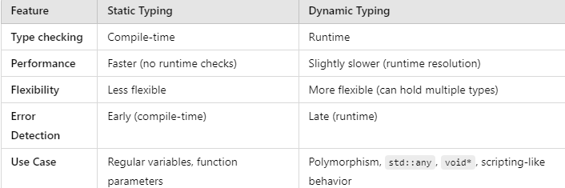

19.Static_cast
Monday, February 10, 2025
7:47 PM

- Static cast is a type-safe cast used for conversion between related type.
- It’s a compile time cast used for safe and explicit type conversions in c++
USECASES OF STATIC_CAST
- Basic type conversions(Primitive types)
  - Used to convert b/w fundamental datatypes such as int->double,char->int etc
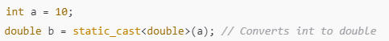
- Upcasting(Derived->Base)
  - Used to convert a derived class pointer/reference to a base class pointer/reference.
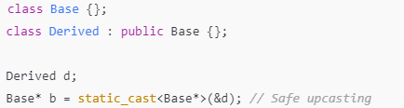
- Convert void* to another type
  - Used to convert void* back to its original type.
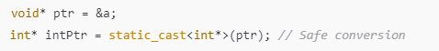
- Conversion b/w related enums and Integer types
  - Used to convert b/w enum and int safely .

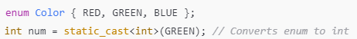

20.Dynamic Cast
Tuesday, February 11, 2025
7:25 PM
- Dynamic_cast is a runtime type conversion operator used primarily for safely downcasting in polymorphic inheritance .
- When to use dynamic cast?
  - When casting from a base class to derived class in a polymorphic hierarchy.
  - Check if an object belongs to a derived type before checking its members.
- How dynamic_cast works?
  - It works only with pointers and references to polymorphic base classes(i.e base class with atleast one virtual function).
  - If the cast is valid,
    - returns a pointer/reference to the derived type.
  - If the cast is invalid
    - For pointers (Base* -> Derived) ,it returns nullptr
    - For references(Base& -> Derived&),it throws std::bad_cast
USE CASES :-
- Safe Downcasting using dynamic_cast

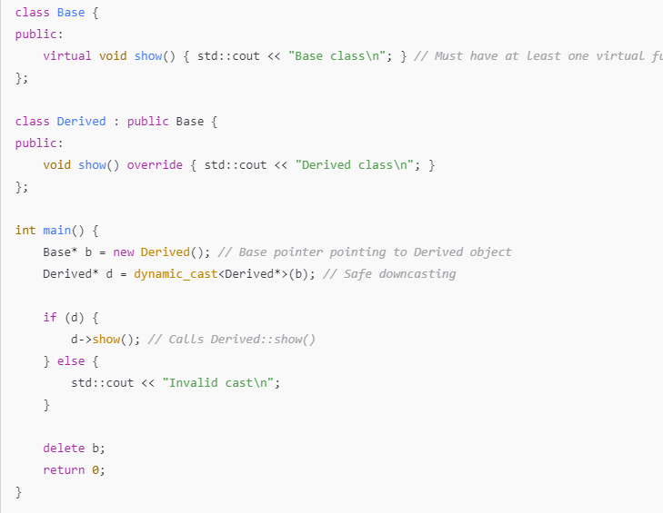
Output :- Derived Class
- Failed dynamic_cast returns nullptr
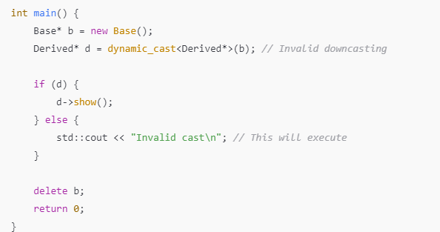
Output :- Invalid cast
- Using dynamic_cast with references
  - If we dynamic_cast a reference,it throws an exception if the cast is invalid.
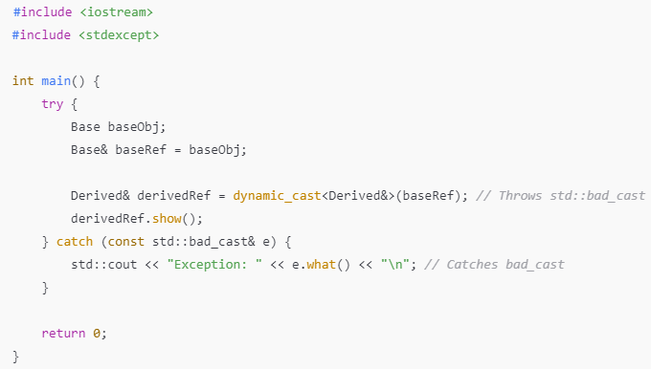
Output :- Exception: std::bad_cast
- Dynamic_cast is used for runtime type safety in polymorphic inheritance.
STATIC_CAST vs DYNAMIC_CAST

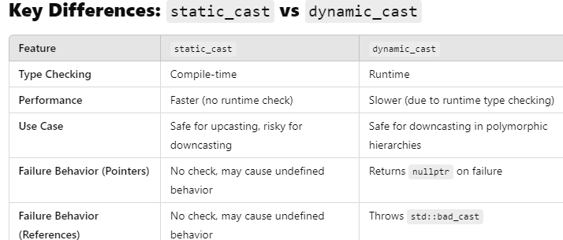

21.Reinterpret Cast
Tuesday, February 11, 2025
7:25 PM
- reinterpret_cast is used for converting one type to another type with different memory representations.
- Its generally used for bitwise reinterpretation of memory.
When to use reinterpret cast?
- For conversion b/w pointer types (e.g int*-->char*)
- Casting b/w integer types and pointers (e.g uintptr_t --> void*)
- For performing bitwise conversion where typesafety is not a concern.

USECASES :-
- Pointer Conversion(int* -> char*)
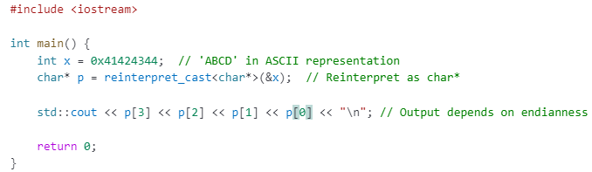
Output:- ABCD
ii. Casting pointer to int and viceversa
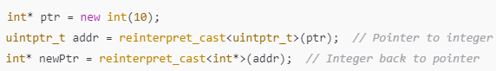
iii.Interpreting Raw Binary Data
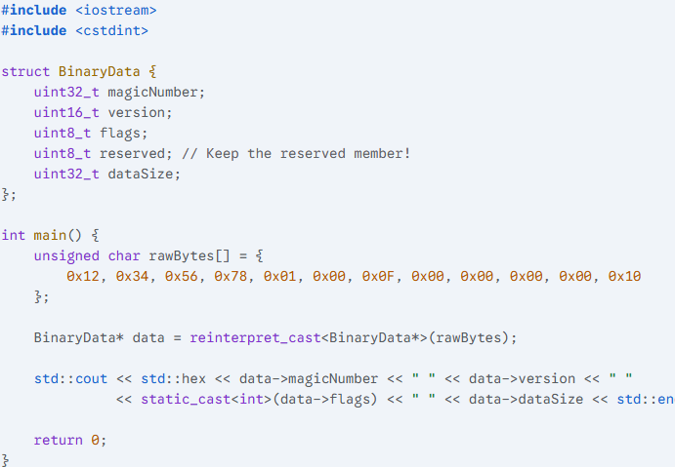
- Used when dealing with n/w packets or binary file parsing.
iv. Interfacing with Hardware(Memory-mapped Registers)

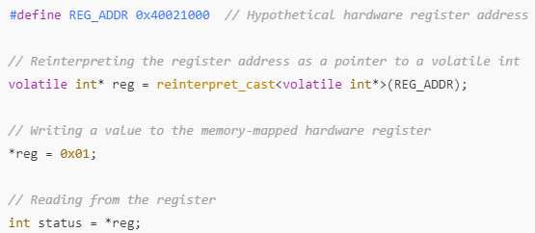

22.Const cast
Tuesday, February 11, 2025
7:27 PM

- const_cast in c++ is used to remove the const or volatile qualifier from a pointers/reference .
KEY POINTS :-
- const_cast can only be used on pointers or references to change their const or volatile qualifications.
- Cannot be used to cast away const from variables originally declared as const(results in undefined behavior)
USECASES
- Removing const to modify a variable
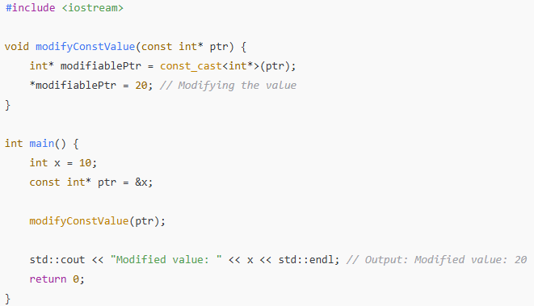
UNDEFINED BEHAVIOR:- Casting away const from truly const variable
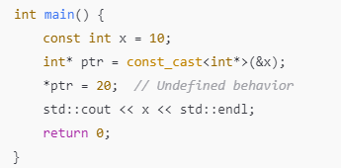
- Since x is originally const,modifying it after casting leads to undefined behavior .
- const_cast with member functions
  - When a member function should not modify an object but needs to call a non-constant member function const_cast can be used.
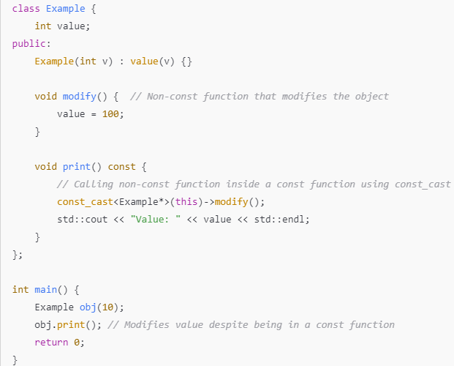

23.Derived Class Memory Layout (Single Inheritance)
Wednesday, February 12, 2025
  - A derived class object is stored in Memory as a Based class object followed by derived class part
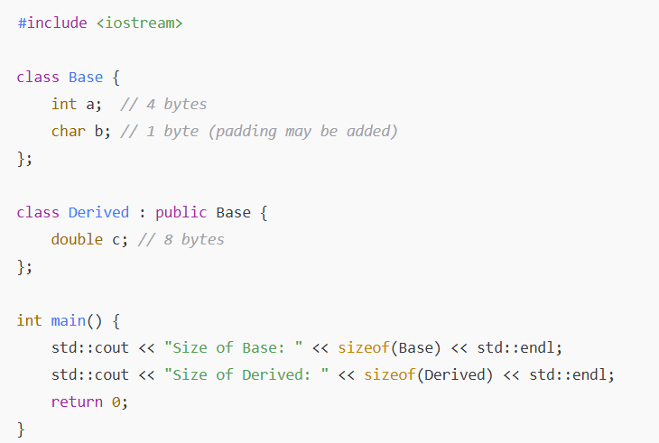

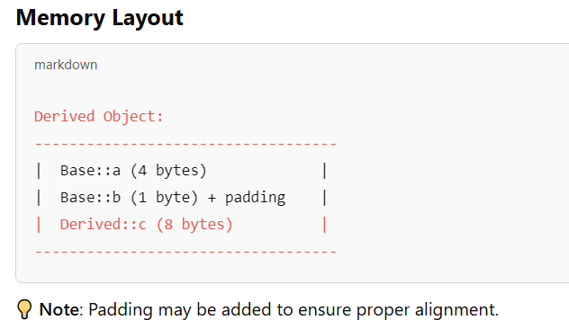
  - When an object is created,base class constructor is called first followed by derived class constructor
  - When object is destroyed,derived class destructor is called first followed by base class

24.Final keyword C++11
Thursday, February 13, 2025
3:09 PM
- final keyword in c++ is used to prevent further inheritance of a class or override a virtual function.
USE CASE :
- Prevent Class Inheritance
- A class marked as final cannot be inherited by other classes.
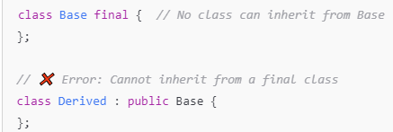
- Preventing function overriding
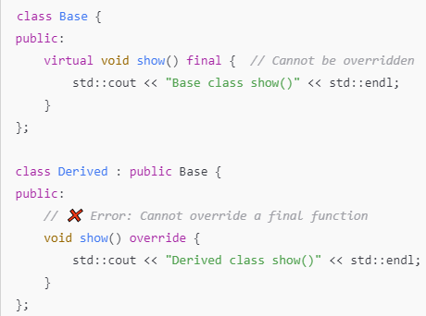
- Virtual function marked as final cannot be overriden in the derived class
USES
- Final prevents unintended inheritance and modifications to virtual functions.
- Used in large projects to ensure strict class hierarchies.
- Avoids accidental override,making code more robust

25 Static vs Dynamic Binding
Friday, February 14, 2025
9:32 AM
- STATIC BINDING (Early binding)
- Static binding happens at compile time
- function call is resolved based on the type of pointer /reference at compile time
- Used for non-virtual functions.
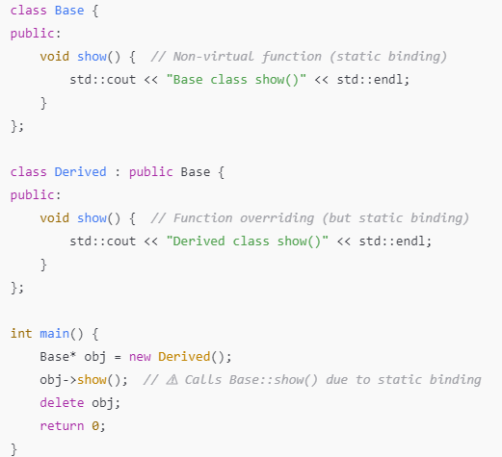
- Eventhough base class pointer obj points to derived object,Base::show is called because static binding is based on pointer type (Base*)
- DYNAMIC BINDING(Late binding)
- Dynamic binding happens at runtime .
- The function call is resolved based on actual object type.
- Used for virtual functions.
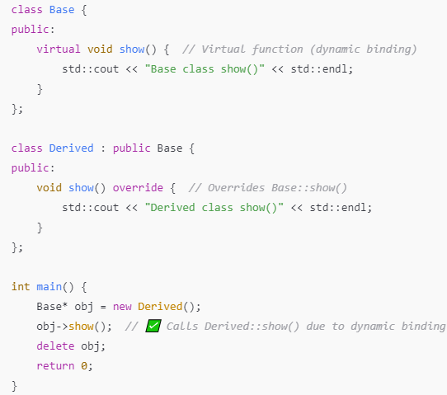
- Since show() is virtual ,function call is resolved at runtime based on actual object type(Derived)

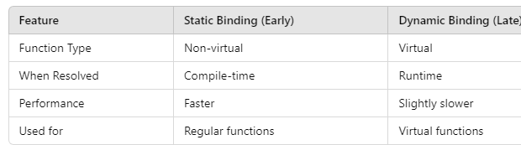

26.Abstract Base Class
Friday, February 14, 2025
9:43 AM

  - Abstract base class in c++ is a class that cannot be instantiated and is meant to be inherited by the other classes.
  - Abstract base class should contain atleast one pure virtual function.
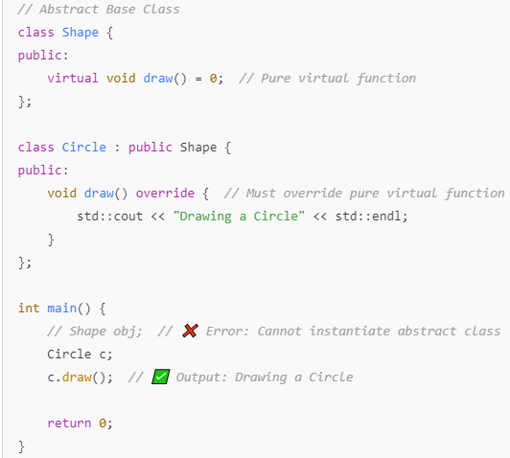
  - Abstract base class provides a blue print of the derived class.
  - Abstract base classes are useful for defining interfaces and enforcing structure in OOP.

27.Object_Slicing_In_C++
Friday, February 14, 2025
9:54 AM
- Object slicing occurs when an object of derived class is assigned to a base class type.During the process derived class-specific attributes and methods are sliced off and only base class part of object is retained.
- In c++,base class variable can only hold the base class part of object and derived class part is discarded.
- Why does object slicing happen?
  - Base class object can retain only the base class datamembers/function and is not aware of the extra members/functions in the derived class part

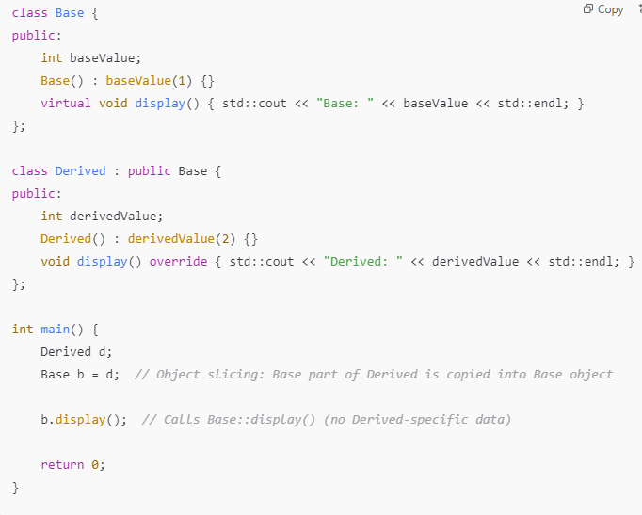
HOW TO AVOID OBJECT SLICING
- Object slicing can be avoided using pointers or references instead of copying objects.
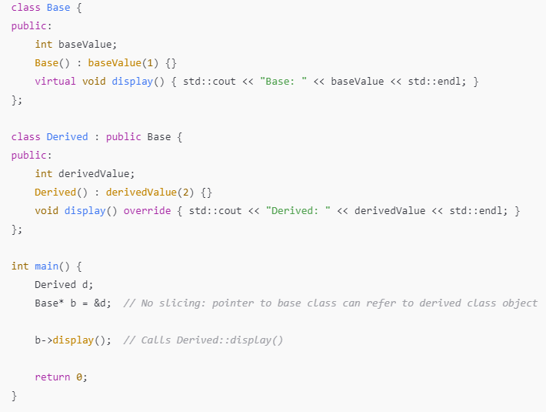

28.Member Function vs Virtual Member Function Implementation in C++
Friday, February 14, 2025
10:22 AM
MEMBER FUNCTION IMPLEMENTATION
- Member functions are not stored in the object ,they are implemented as global Functions
- When member function is called,a pointer to the object is passed as an extra argument called "this".
VIRTUAL MEMBER FUNCTION IMPLEMENTATION
- When compiler encounters a class which has a virtual member function.It will create and populate a Datastructure
  - It’s the virtual member function table ,known as vtable.
  - vtable is an array of pointers to member function
- When compiler sees a virtual function ,it will generate some extra code
  - The extra code will be executed at runtime
  - It checks the dynamic type of the object
  - It uses vtable to call the correct version of the function
VIRTUAL FUNCTION OVERHEAD
- Calling a virtual function takes longer time than for a non-virtual function (20-25% more time).
- Memory Allocation
  - Each class that has a virtual member function needs a vtable
  - A pointer is needed for each member functions in the class

29.Polymorphism (Static / Compile time)
Friday, February 14, 2025
10:43 AM
  - Polymorphism allows a single function,operator or an interface to work in different ways.
  - COMPILE TIME POLYMORPHISM
  - Compile time polymorphism is achieved by defining multiple function with the same name but different implementation.
    - Function overloading
      - Multiple functions with same name but different parameters.
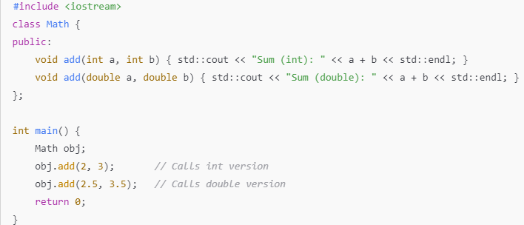
  - Operator overloading
    - Operators can be overloaded to work with user-defined types
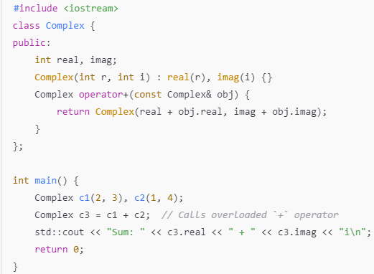
  - Function Templates(Template polymporphism)
    - Templates allow generic programming where a function works with multiple data types.
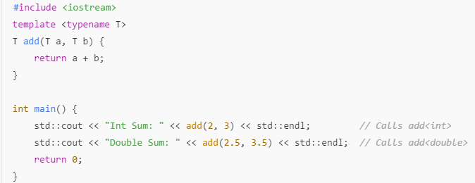

30.Dynamic Polymorphism(Runtime Polymorphism)
Friday, February 14, 2025
10:43 AM
  - Dynamic Polymorphism allows objects of different classes related by inheritance,to be treated as object of a common base class.
Key Features of Runtime Polymorphism
✔ Achieved using virtual functions in the base class.
✔ Function resolution occurs at runtime using dynamic binding (vtable and vptr mechanism).
✔ Allows extensibility—new behaviors can be added without modifying existing code.
✔ Supports object-oriented principles like abstraction and encapsulation.

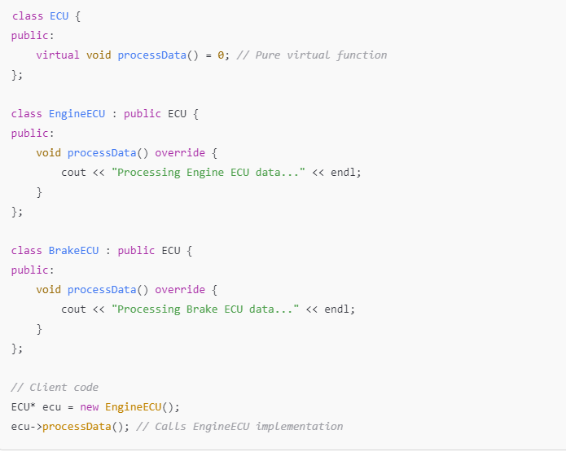
  - Different ECUs(e.g Engine Control,Brake Control) uses the common interface but the implementation logic is different
Working(Vtable & VPtr Mechanism)
  - Each class with virtual function has a VTable,which store the function pointers of the overridden methods
  - Each object of the class(base class having Virtual functions) has a hidden Vptr(Virtual pointer) pointing to the VTable .
  - When a virtual function is called through a base class pointer,the Vtable is used to dynamically bind the function at runtime.

APPLICATION 1 : AUTOSAR RTE INTERFACE
  - AUTOSAR components communicate via standardized RTE(Run time environment) interfaces ,allows different software components to be swapped without modifying the common logic
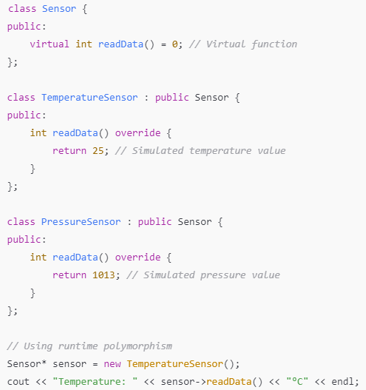

  - Here there is a common interface for sensor communication,different sensors implement their specific logic .
  - ✔ Benefit: Enables sensor abstraction, making it easier to switch or upgrade sensors without modifying core software.

APPLICATION 2 : AUTOSAR RTE INTERFACE
  - Adaptive AUTOSAR uses service-oriented architecture,where applications dynamically request services
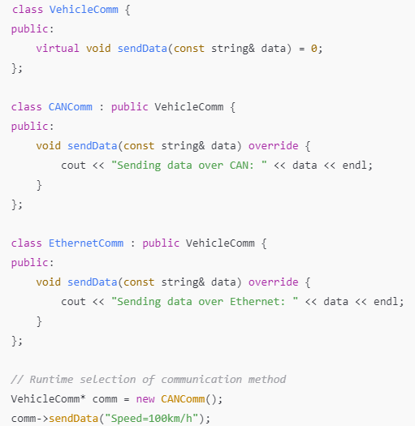
  - A common Vehicle Communication Interface where different vehicle platforms implement their protocol (CAN,Ethernet,etc)
Benefit: Enables dynamic switching between communication protocols based on ECU capability.

PRACTICAL EXAMPLE
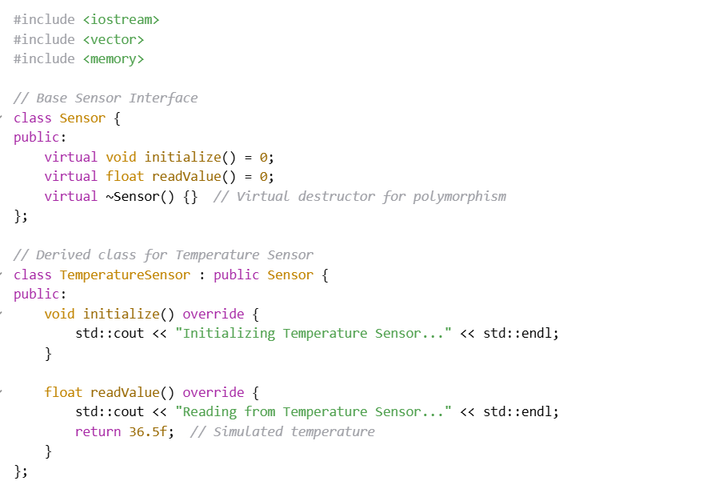

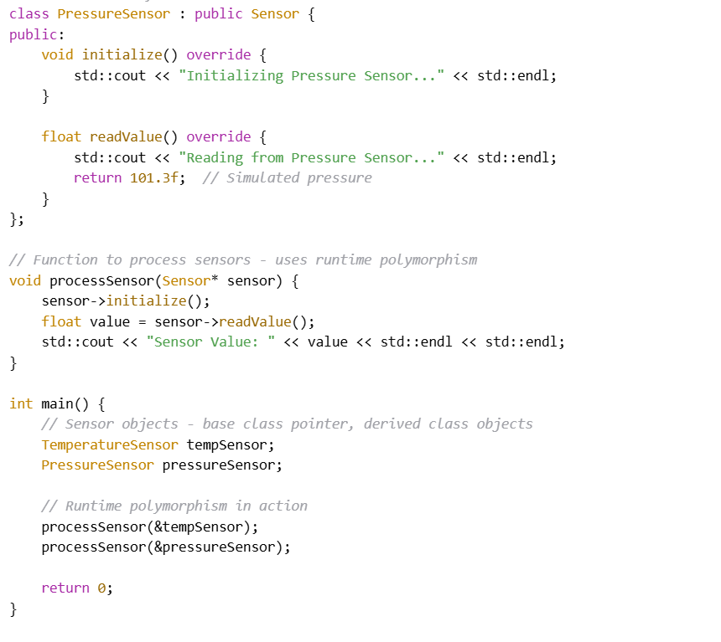
🧠 My Practical Example: Sensor Abstraction in Embedded Systems
In my example, I’ve designed a base class called Sensor, which acts as an abstract interface for any type of sensor in an embedded or automotive system. It defines two virtual functions: initialize() and readValue().
Then I have two derived classes:
  - TemperatureSensor
  - PressureSensor
Each of them implements these methods with sensor-specific logic.
In the main() function, I use base class pointers to handle both sensor types without knowing the exact sensor at compile time. The correct method gets dispatched at runtime, thanks to virtual function overriding.

HOW FUNCTION RESOLUTION HAPPENS AT RUNTIME
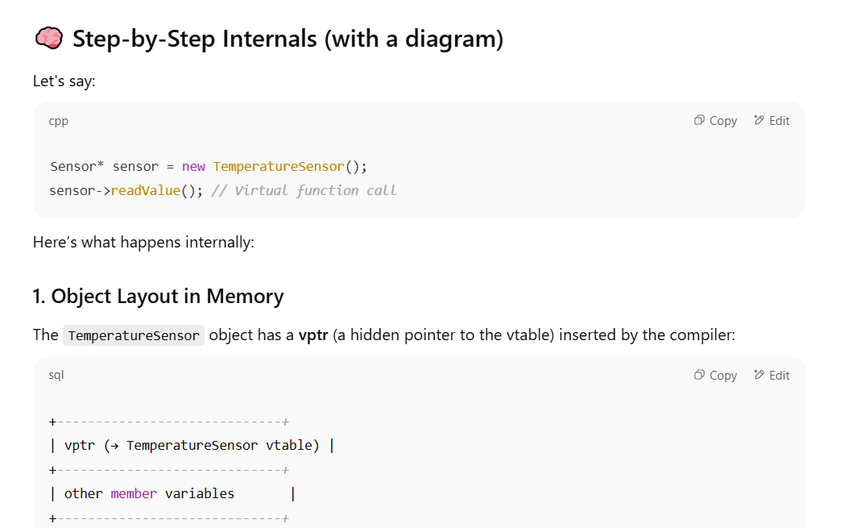

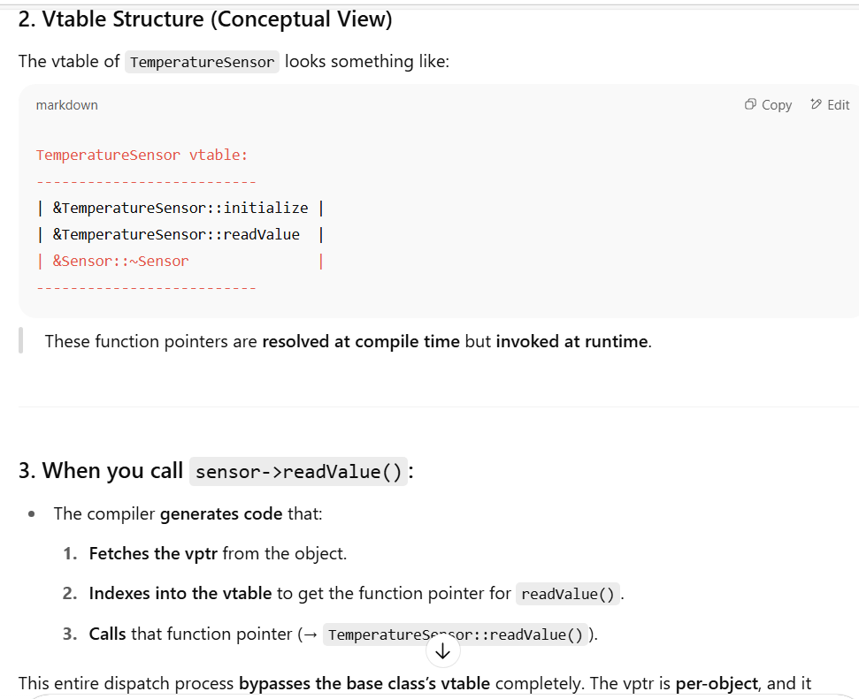

31.Multiple Inheritance
Friday, February 14, 2025
2:12 PM
- Multiple Inheritance is a feature in C++ where a class can inherit from more than one base class.
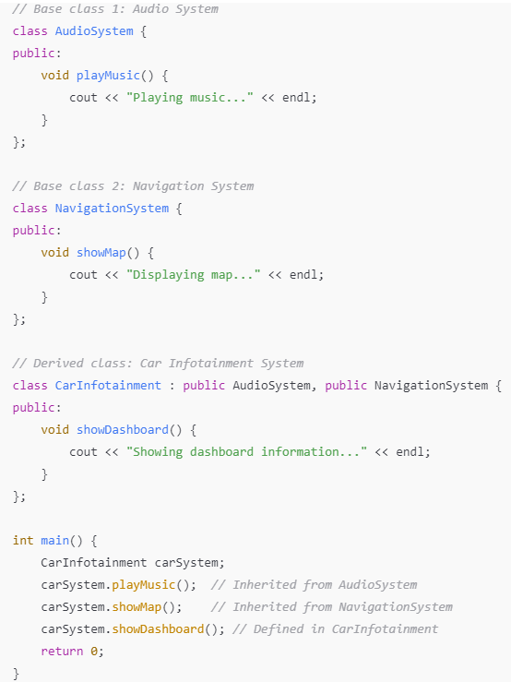
- Infotainment system can reuse both audio and navigation functionalities.
USECASES:
- A security module can inherit both from Encryption Module and Logging Module .
- A device driver inherit from both HardwareController and SoftwareInterface.

32.Diamond Problem in Multiple Inheritance
Wednesday, February 19, 2025
11:03 AM
- When 2 baseclasses inherit from the same grantparent class and a derived class inherits from both,duplicate copies of the base class exist.
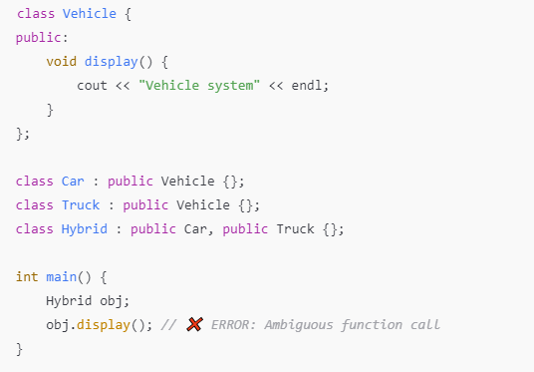
- Hybrid inherits display() from both Car & Truck ,causing ambiguity.
Solution:- Use Virtual Inheritance
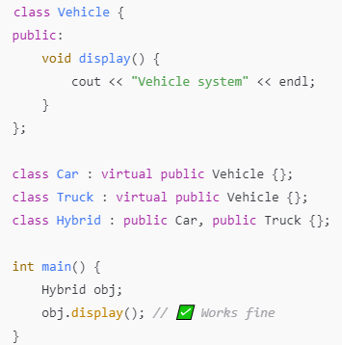
- Only one copy of Vehicle exists,preventing ambiguity
- Virtual Inheritance makes sure that only one shared instance of Vehicle::display() exist .

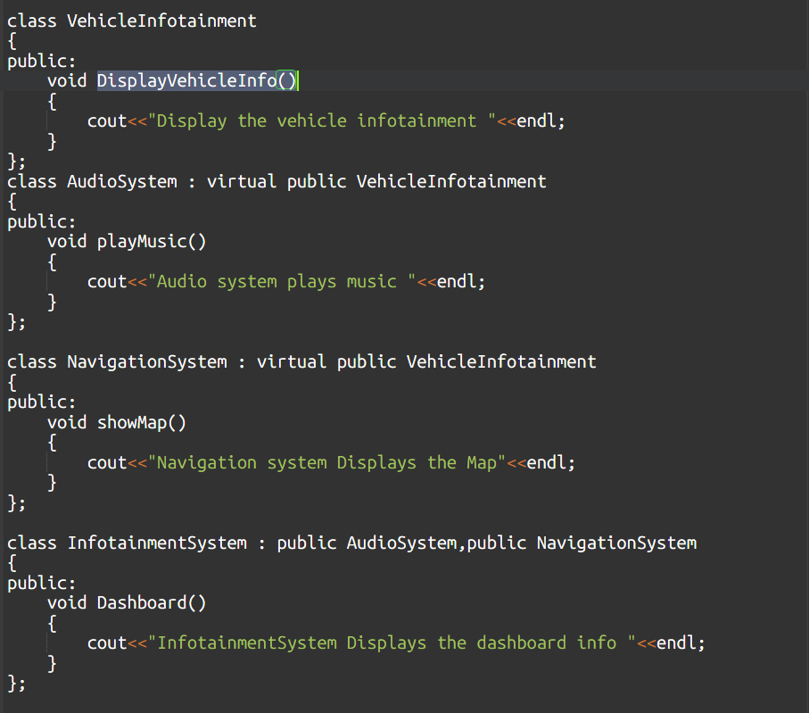
Without Virtual Inheritance
class Hybrid
├── AudioSystem
│ └── VehicleInfotainment (copy 1)
└── NavigationSystem
└── VehicleInfotainment (copy 2)
With Virtual Inheritance
class Hybrid
├── AudioSystem
├── NavigationSystem
└── VehicleInfotainment (single, shared copy)

33.Virtual Inheritance
Friday, February 14, 2025
3:14 PM
  - Virtual Inheritance is a mechanism in C++ that prevents multiple copies of base class when using multiple Inheritance .
  - Virtual Inheritance solves diamond problem,where a derived class inherits from 2 base classes,both Inherits from a common ancestor.
  - It ensures a single shared instance of base class.
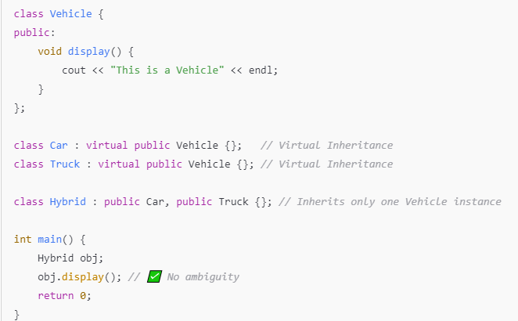
  - Only one copy of grantparent class Vehicle exists ,avoiding ambiguity.
Working
  - Without Virtual Inheritance : Each derived class (Car,Truck) creates its own copy of vehicle.
  - With Virtual Inheritance:- Only one shared copy of Vehicle exists for derived class.
  - Compiler internally adjusts pointer(VPTR)so that Hybrid class correctly refers to a single Vehicle instance.

34.Virtual Destructor
Tuesday, February 18, 2025
10:39 AM
  - Virtual Destructor in C++ ensures that when deleting an object through a base class pointer,the derived class destructor is also invoked properly.It prevents memory leaks and ensures proper cleanup of dynamically allocated resources.

Without Virtual Destructor
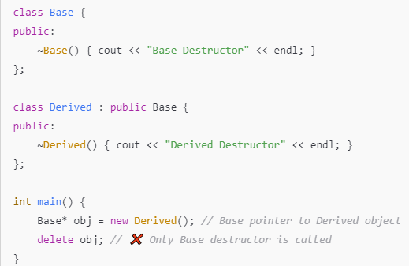
  - Derived class destructor is never called,causing memory leak as resources allowed to derived class is never freed.
Use Virtual Destructor
  - When base class destructor is virtual,derived class destructor is also invoked,ensuring proper cleanup
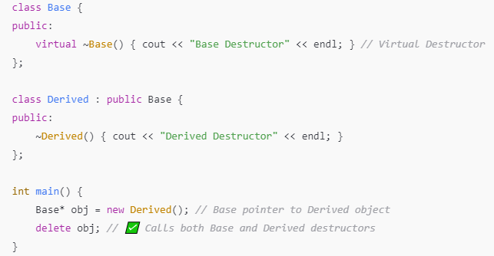
  - Now both destructors are being invoked,preventing memory leaks.

35.No_except and move
Monday, March 3, 2025
8:12 PM

✅ noexcept in C++
🔹 What is it?
- noexcept is a C++ specifier that tells the compiler a function does not throw exceptions.
🔹 Why use it?
- Helps with optimization.
- Ensures strong exception safety.
- Makes move operations more efficient (especially with containers like std::vector).
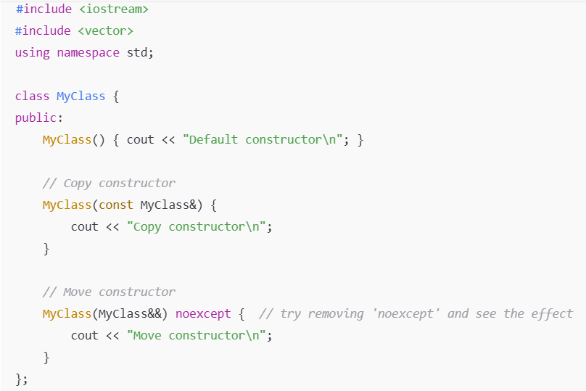

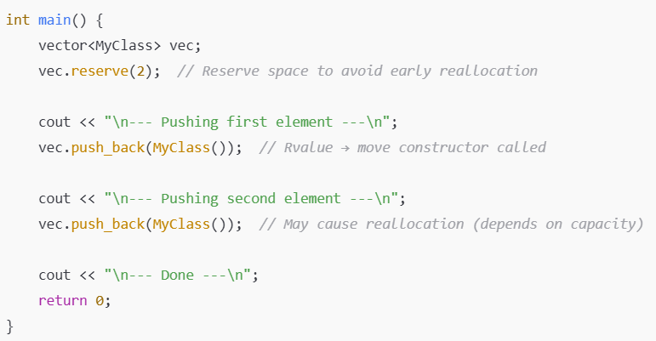
🔍 What This Shows
- std::vector will use the move constructor if it's available and marked noexcept.
- If noexcept is not present, std::vector might fall back to copy constructor for safety during reallocation.
- When you push the second element, reallocation may occur — this is when move/copy is chosen depending on noexcept.
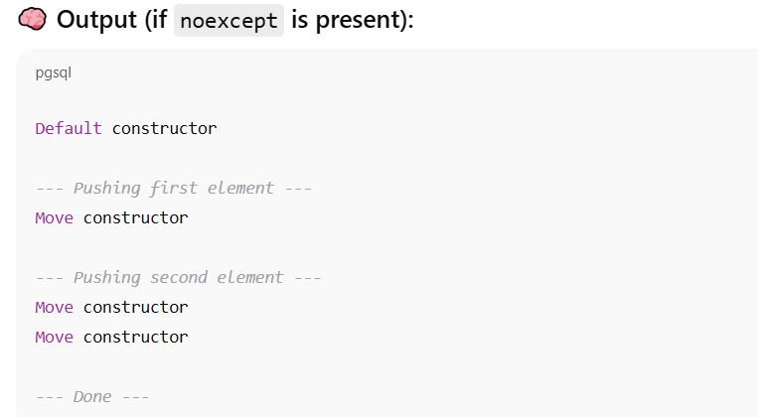

36.Move constructor
Monday, March 3, 2025
8:15 PM
  - Move constructor in C++ is a special constructor used to create a new object by transferring resources from an exisitng object instead of copying them .
  - It allows efficient transfer of ownership ,when dealing with dynamic memory or expensive to copy resources.
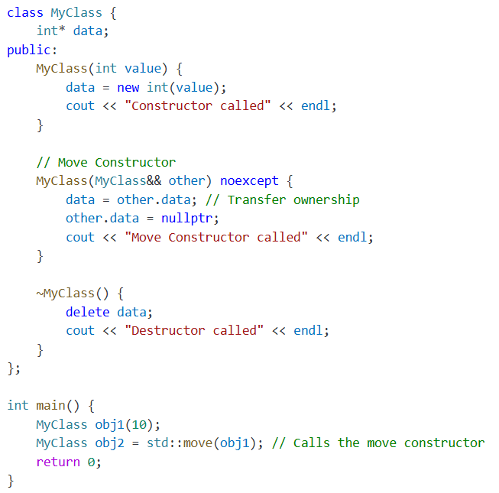
  - Move constructor helps to avoid unnecessary heap allocation and copying.

37.Template Functions & Classes
Friday, March 21, 2025
3:48 PM
- C++ Templates are used to create generic and reusable code.
- TEMPLATE FUNCTION
- Template function allows the same function to work with different datatypes.
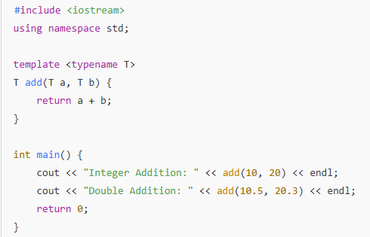
- template<typename T>:- Declares a template where T is the placeholder for a datatype.
- The function add works with any type(int,float etc).

- TEMPLATE CLASSES
- Template class allows the same class to work with different types of data
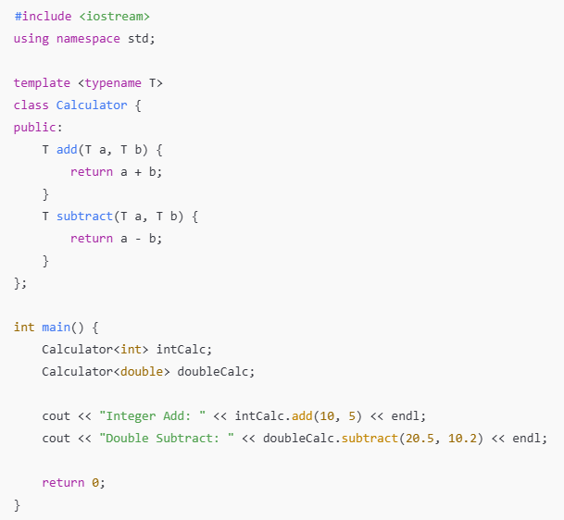
- Calculator<T> is a generic class where T can be any type.
- We can create instance of Calculator for int,double or any other type.

38.Lexical_cast<Boost_Library>
Friday, March 21, 2025
10:23 AM
  - boost::lexical_cast is a type-safe and convenient way to convert between datatypes (usually b/w strings and numeric types) using C++ streams internally .
    - C++ equivalent of std::stoi, std::to_string, but more generic and powerful.
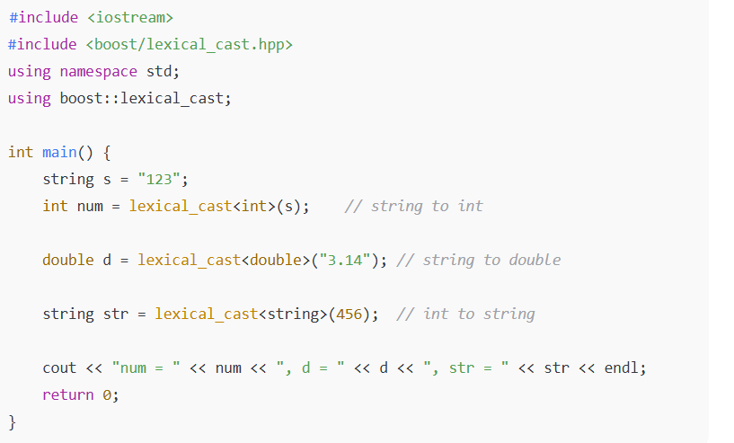

39.Tuple in C++
Sunday, April 6, 2025
7:31 PM
  - std::tuple is a fixed-size collection of heterogenous values-It can hold elements of different types.

  - Accessing Tuple Elements
  - Use std::get<index>(tuple)
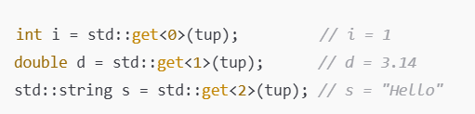
  - Creating Tuples
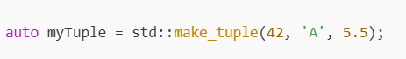
✅ Key Features
  - Heterogeneous Storage: Can store different types together.
  - Fixed Size: Size is known at compile time.
  - Access by Index: Use std::get<index>(tuple) to access elements.
  - Return Multiple Values: Useful for returning more than one value from a function.
  - Structured Bindings (C++17): Easy unpacking of tuple into separate variables.
  - Tie for Ignoring: Use std::tie to unpack or ignore certain values.
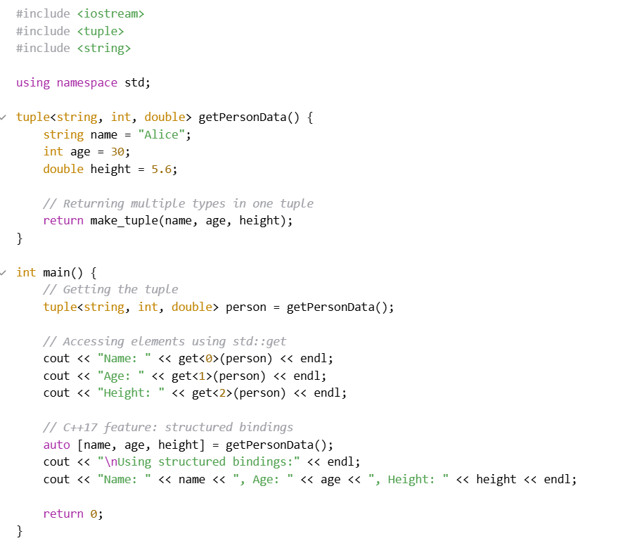
✅ What is Structured Binding in C++ (especially with std::tuple)?
Structured bindings (introduced in C++17) allow you to unpack (or decompose) tuple-like objects into individual named variables in a clean and readable way.
Instead of accessing elements like this:

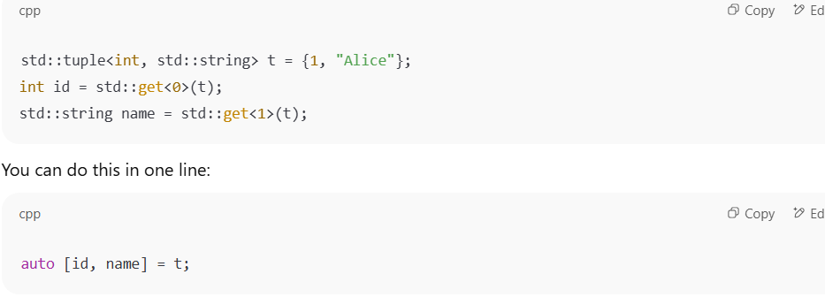
  - Std::tie
🔹 What is std::tie?
std::tie is a utility that creates a tuple of references to existing variables. It's mainly used for:
  - Unpacking tuple values into variables
  - Ignoring certain tuple elements
  - Lexicographic comparison using tuples
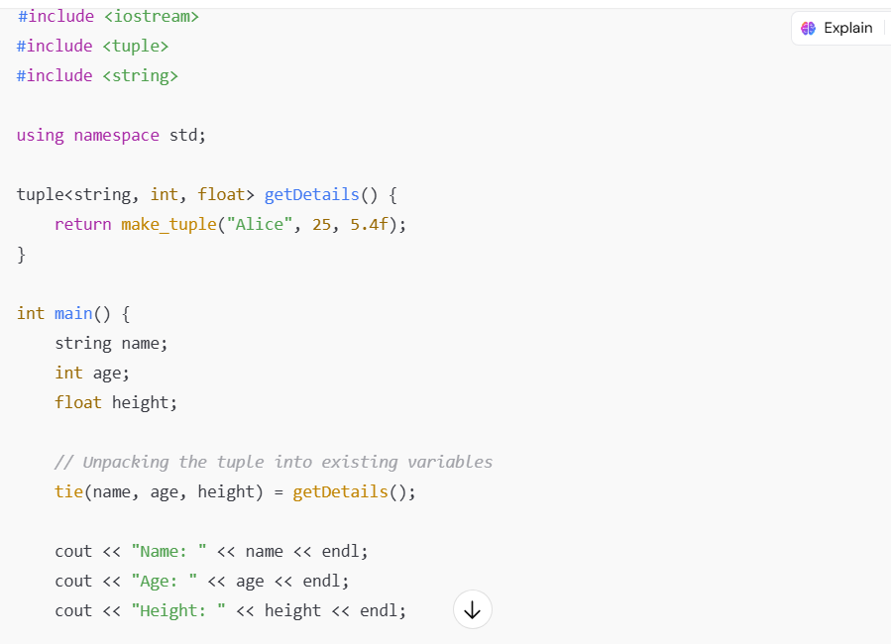

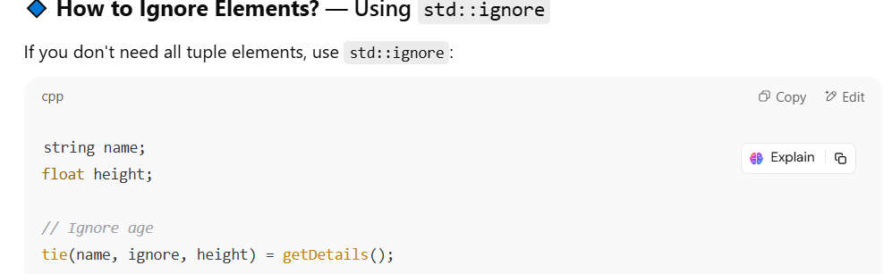

40. Drawbacks of std::vector
Sunday, April 6, 2025
10:08 PM
  - Contiguos Memory Needed :- Vector requires large contiguos memory block ,which can be inefficient for very large data.
  - Thread Safety :- Std::vector is not thread safe without external synchronization .
  - Over allocation of Memory :- To reduce reallocation ,vector often over -allocate resulting in wastage of memory.
  - Costly insertion & deletion :- Inserting /deleting element (not at end) required shifting all subsequent elements.Which us costly

41.Explicit constructor in C++
Sunday, April 6, 2025
11:06 PM

  - Making a constructor explicit prevents implicit conversions and copy initialization
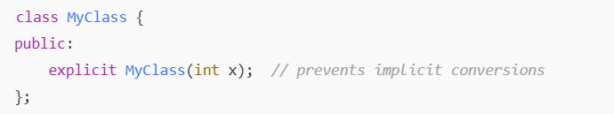
  - Without explicit ,compiler allows implicit conversions like ..
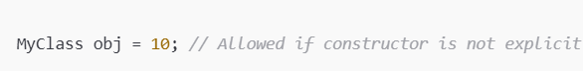
  - With explicit,its not allowed and ensures type safety.
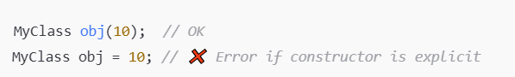

42.Malloc vs Calloc
Sunday, April 6, 2025
11:14 PM
- Malloc() just returns the raw block of memory ,while calloc() fills the memory with zero and return
- There is an extra step in calloc() that makes it slower than malloc().
When to use malloc() vs calloc()?
- Use malloc() when we want to immediately overwrite the memory.
- Use calloc() when you need zero-initialized memory(like arrays or structs with all-zero defaults).

43.This pointer in C++
Monday, April 7, 2025
9:44 AM
  - this pointer is a const pointer to non static members & member functions of a class .
    - Static member functions are not bound to an object hence no this pointer
  - Used to access or return the current object
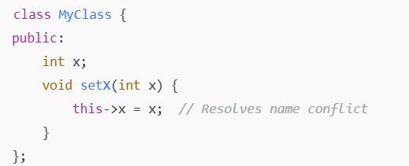
📦 How does this reach the member function?
  - When a member function is being called
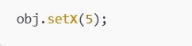
Its internally translated by the compiler as

  - this is automatically passed as a hidden argument

44 . Function hiding in C++
Monday, April 7, 2025
10:09 AM
- Funtion hiding occurs when derived class declares a function with the same name as in base class.This causes the base class version to be hidden .
- Name-based hiding (not just signature-based!)
  - If a derived class declares a function with the same name as a function in the base class, all overloaded versions in the base with that name are hidden.
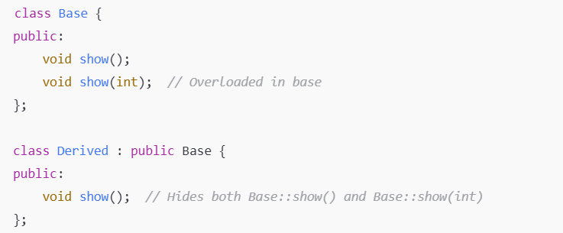
- Derived::show() hides both Base::show() and Base::show(int).
⚠️ How to fix it?
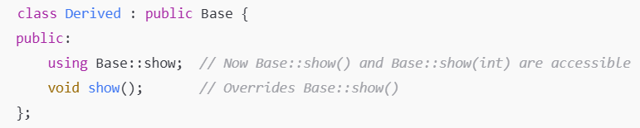

45.Const pointer vs pointer to const
Monday, April 7, 2025
10:42 AM
- Pointer to const

- Pointer points to a value which is const
- We can change the pointer ptr = & other ;
- We cannot change the value that the pointer points to (*ptr = 10; ❌)
- Const Pointer
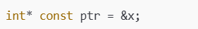
- Pointer which is const points to an int value
- We cannot change the pointer (ptr = &y; ❌)
- We can change the value it points to (*ptr = 10; ✅)

iii. Const Pointer to const

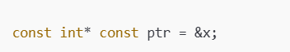
- You cannot change the pointer
- You cannot change the value it points to

46.Thread Synchronization Mechanism
Monday, April 7, 2025
11:19 AM
- MUTEX
- Mutex ensures that only one thread can enter critical section at a time .
Usage :
- Protect shared data (counter,file,containers)

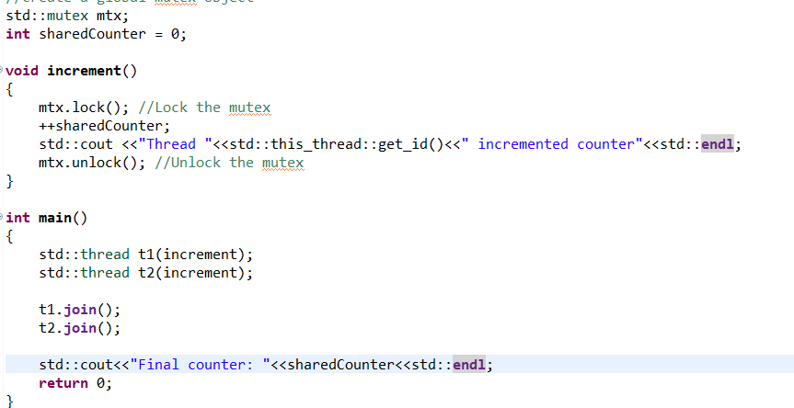
- Semaphore (POSIX in linux)
- Semaphore controls the access to a resource pool with fixed number of slots
- Usage :
  - Limiting threads (e.g only 3 threads can access a database at once )
✅ Better Semaphore Example: Connection Pool Simulation
Let's simulate a connection pool of size 3, and 6 threads (clients) trying to access it.

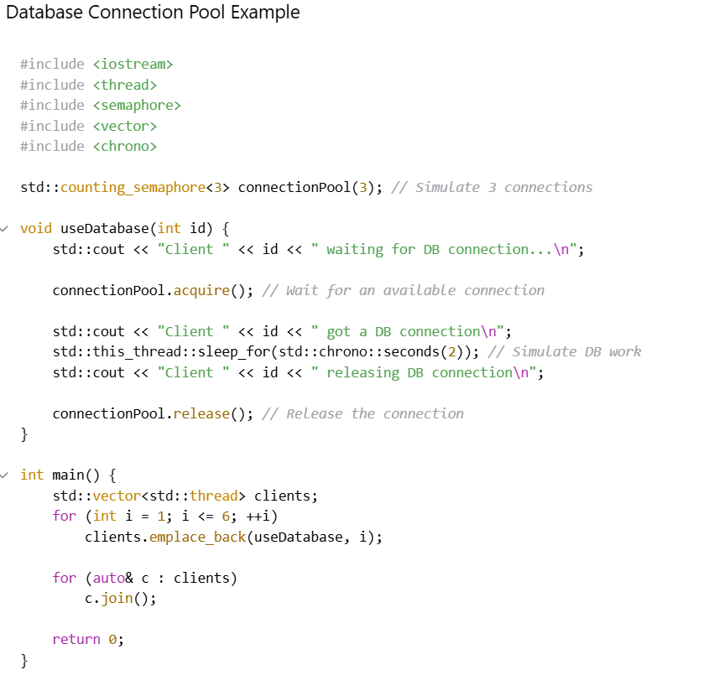

This program simulates a scenario where multiple threads (clients) attempt to access a limited shared resource — a connection pool.
- There are 6 client threads, but only 3 connections are available at any given time.
- A counting semaphore is used to control access to the shared resource.
- Each thread must wait for an available connection if all are in use.
- Once a connection is available, the thread "acquires" it, simulates some work (e.g., accessing a database), and then releases the connection back to the pool.
- This ensures that no more than 3 threads access the resource simultaneously, mimicking how a real connection pool limits concurrent usage.

Iii. Conditional Variables

- Allows a thread to wait for a condition to be true before proceeding.
✅ When to use:
- Producer/Consumer patterns
- Waiting until a queue is not empty
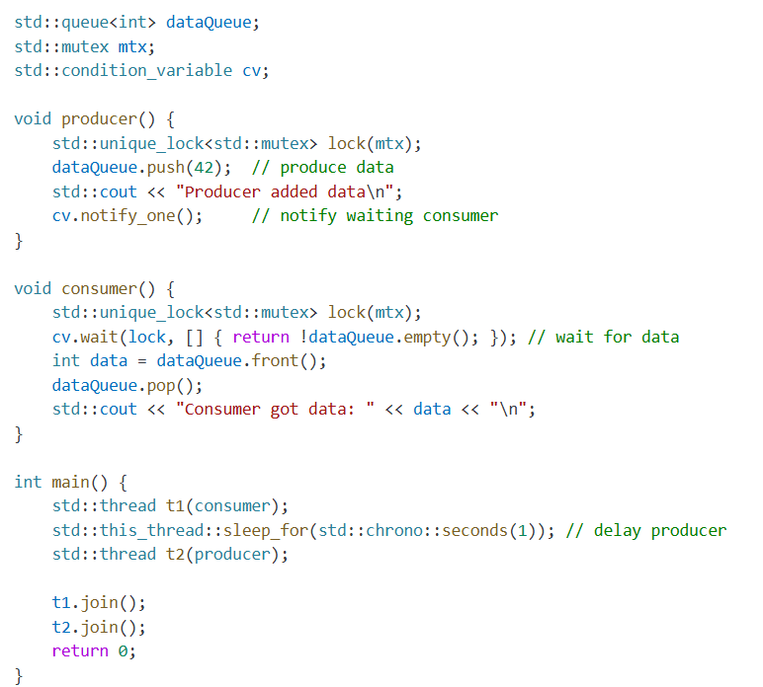
Note : Mutex will get automatically unlocked when the lock goes out of scope
Iv. Atomic Variable(std::atomic)
- A variable that is thread-safe without locks .
- Use case :
  - Simple Counter/flags that needs to be updated safely from multiple threads

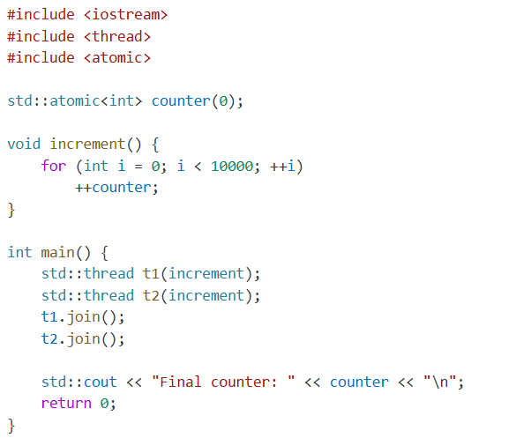

47. NULL vs nullptr in C++
Thursday, April 10, 2025
11:12 AM

  - NULL (Legacy -C /Old C++)

  - Type :- Typically defined as #define NULL 0 or (void*)0
  - Drawback :- Can cause ambiguity in function overloads due to being just an integer literal .
Problematic Cause
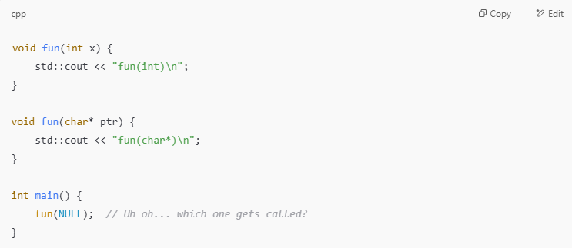

  - NULL is usually defined as 0.
  - fun(0) matches fun(int) perfectly, so it chooses the int version.
  - Even though logically you might have wanted to call fun(char*).
  - nullptr (Modern C++ — C++11 and later)

  - Type: nullptr is of type std::nullptr_t
  - Purpose :- Introduced to provide a type-safe null pointer constant
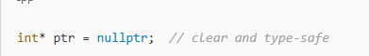
How nullptr avoids ambiguity
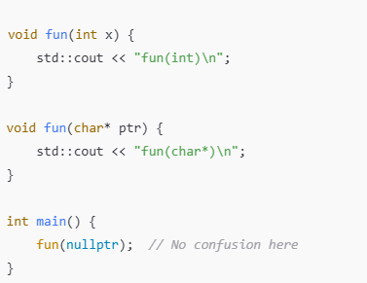

  - nullptr is not an int — it’s of type std::nullptr_t.
  - It can convert only to pointer types, not to int.
  - So fun(char*) is the only match. No ambiguity. 🎯

48.Static Declaration in Header vs Global declaration in Header
Friday, April 18, 2025
6:54 PM

  - Global Declaration in Header File

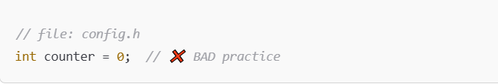
  - When we declare a variable without static in a header file and include it in multiple .cpp files.
  - Each source will have its of copy of counter and we will get multiple definition error at linking time.
Right way to use global variables in header
✅ Step 1: Use extern in the header
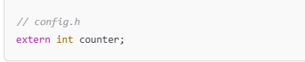
✅ Step 2: Define it in one source file
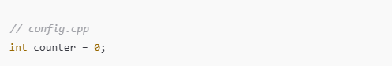
  - Now everyfile including config.h refers to the same global variable
  - Static Declaration in Header File
  - When we declare a variable as static in a header file.
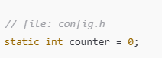
  - The .cpp file that includes this header gets its own private copy of the counter,hence there wont be any linking error
  - Every variable has a separate copy ,not shared
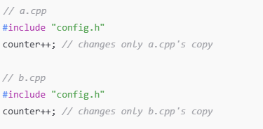

49.Thread vs Process
Monday, April 21, 2025
7:36 AM

- Process
- A process is an independent program in execution
- Process has its own memory and is not shared
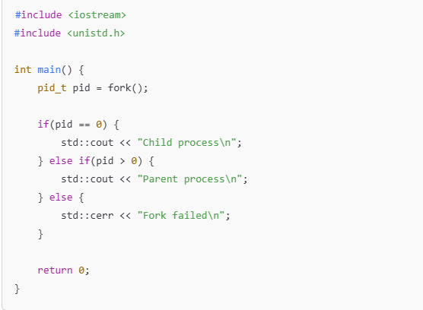
- fork() creates a new process(child) with its own memory.
- Parent and child does not share variables directly ,we need pipes/shared memory for communication.
- Crash of one process does'nt affect the other . If parent process crashes ,child wont get affected or viceverse
- Thread
- A thread is a small executable unit within a process. It represents a single sequence of instruction that runs independently while sharing process resources like memory and file handles.
- Multithreading :- allows the thread to run concurrently within the same process.
- Each thread will have its own stack but heap memory will be shared
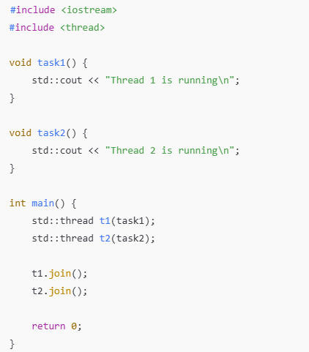
- 2 threads are created within the same process. They share memory and can be communicated easily through varaibles.
- Crash of one thread will affect the other
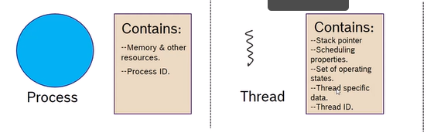
🧪 Real-world Analogy
Imagine MS Word as a process.
Inside Word:
- One thread handles typing
- Another handles spell check
- Another handles auto-save
These are threads — doing different tasks within the same app, sharing memory and resources.
But if you open MS Word and Chrome, each is a separate process.

50.Thread Management
Tuesday, September 2, 2025
8:51 AM

  - Threads allow us to effectively use the available CPU cores in a processor .
  - Threads provides a mechanism to effectively use the available core by suspending threads waiting for an external event such as IO .

THREAD STATES
  - BLOCKED
  - A thread can be in a BLOCKED state when it does not want any CPU time or is waiting for some external event to happen
  - There are several blocked states depending on what the threads are waiting for
    - REPLY -> Waiting for IPC reply
    - MUTEX ->Waiting for MUTEX
    - MESSAGE ->Waiting for Message to receive
  - READY :- A thread is in READY state when its ready for execution.
  - RUNNING :- A thread is in running state when it has the CPU time .

50.Virtual Memory & function resolution using vtable in C++
Monday, April 21, 2025
9:37 AM
- Virtual memory ,allows the C++ programs to use more memory that is physically available to the system by utilizing the disk space as an extension of RAM .
- Virtual memory is managed by the operating system . When we dynamically allocate memory using new or malloc,os maps this memory in the process's virtual address space .
- Os handles the translation between virtual address and physical address(actual memory).

Relation Between Virtual Memory and vtable/vpointer in C++
- vtable (virtual table): A lookup table of function pointers created by the compiler for a class with virtual functions.
- vptr (vtable pointer): A hidden pointer in each object that points to the vtable of its class.
- Both vtable & vptr resides in the process's virtual address space .
- vtable is stored in the read-only virtual memory (often in text/data segment of the program).
- Each objects vptr is stored in the heap or stack ,depending on where the object is created .
Function Call Resolution
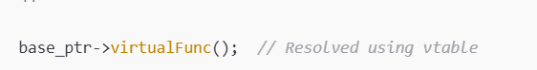
- When we call a virtual function ,compiler generated code to
  - Read the vptr from the object (virtual address).
  - Index into the vtable(also in virtual memory)
  - Jump to the function pointer stored there(virtual address space)
- All the memory access are to a virtual address,which the MMU and OS maps to physical memory.
🧠 Example:
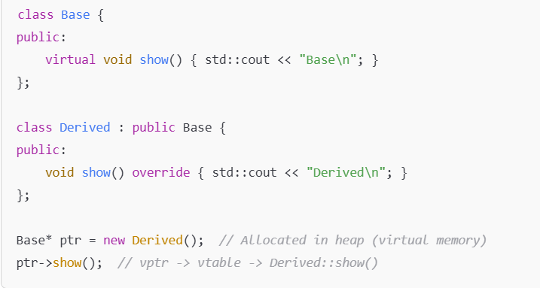
- ptr holds a virtual address to the heap object.
- The object has a vptr -> which points to Derived's vtable.
- Vtable contains a pointer to Derived::show() function in code memory(virtual Memory)
- Final jump is done via virtual address

51.Static vs Dynamic Library
Monday, April 21, 2025
7:58 PM
STATIC LIBRARY
- Static library is basically a collection of compiled code that gets copied directly into your executable when we build the application .
File extension :- .lib(windows),.a(linux).
- Once builded ,we don’t need the binary files anymore as the final binary contains everything.
- Downside :-
  - If the library changes ,we have to recompile our entire project to use the new version .
  - Multiple programs includes its own copy of the code,it can lead to bigger file size and duplicate memory use .

DYNAMIC LIBRARY
- Dynamic Library also called as (shared library or dll)is linked at runtime .
- Our executable code ,just holds are reference to the library and the OS loads it when the app starts.
File extensions: .dll (Windows), .so (Linux)
- Multiple programs can share a single loaded copy in memory ,which saves resources.
- Downside :- We need to make sure the library files are available wherever the app runs.
- If library is updates,we don’t need to recompile the entire application

🛠️ Real-Life Use
- Use static libraries if you're building something self-contained (e.g., embedded systems or command-line tools).
- Use dynamic libraries when working on large systems, apps with plugins, or anything that may require runtime updates or shared components.

52.Object code vs Library vs Executable
Monday, April 21, 2025
8:15 PM
  - Object code (.O/.Obj)
  - It’s the output of compiling a single C++ source file .
  - It’s a machine code ,its not runnable on its own.
  - It have unresolved references (calls to functions defined in other files)
  - Library (.a, .lib, .so, .dll)
  - A library is a collection of object files.
  - It groups useful code,that can be reused across multiple programs
  - Can be static (gets embedded into your app) or dynamic (loaded at runtime).

It’s like a toolbox you carry to different projects.
Static lib: libmath.a
Dynamic lib: libmath.so or math.dll
  - Executable (.exe, no extension on Linux)
  - It’s a final program that we can actually run
  - Created by linking object files into a complete,self contained binary
  - It has all missing references resolved and ready for execution .

53.Segmentation Fault
Monday, April 21, 2025
8:48 PM
- Segmentation fault is a runtime error that occurs when program tries to access memory that it is not allowed to.
When can Segmentation Fault occur ?
- Dereferencing NULL or uninitialized pointers
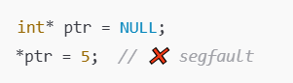
- Accessing memory out of array bounds
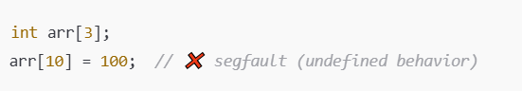
- Using freed memory (dangling pointer)
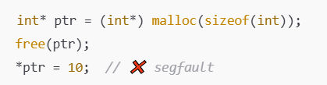
- Stack overflow (infinite recursion )
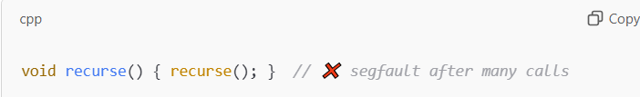

54.Stack overflow (Infinite recursion)
Monday, April 21, 2025
8:55 PM



It might seem like void recurse() { recurse(); } wouldn’t consume stack space since it doesn’t use arguments or local variables — but each function call still needs stack space. Here’s why:

Even without arguments or local variables, every function call does a few things behind the scenes:
- Return Address Storage:
  - When a function is called, the CPU pushes the return address (i.e., where to come back after the function finishes) onto the stack.
- Call Stack Frame Setup:
  - A minimal stack frame is still created — it holds internal bookkeeping info (e.g., return address, saved registers).
- Instruction Pointer Tracking:
  - The program must remember where each call came from, and this info is stored on the stack.
- Each recursive call adds a new frame on the stack. Since there's no base case (i.e., stopping condition), these frames keep stacking up, leading to a stack overflow when the system’s stack limit is exceeded.

55. Abstract Class vs Interface class
Monday, April 21, 2025
8:59 PM

  - Abstract Class
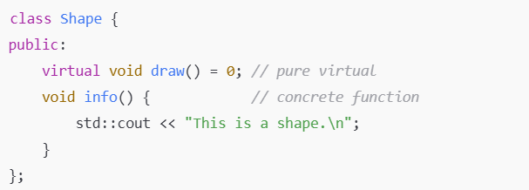
  - An abstract class can have both Implemented(concrete) and pure virtual functions.
  - Its used when we want to share some default behaviour among the derived classes
  - Abstract class cannot be instantiated as virtual functions are anonymous functions.
  - Interface Class
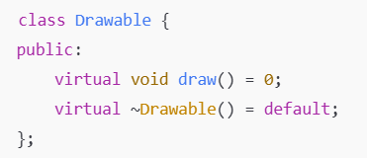
  - Interface classes have only pure virtual functions and no data members or implementations.
⚡ Use Case Summary:
  - Use an abstract class when you want base functionality with optional overrides.
  - Use an interface when you want to enforce a strict contract for derived classes without enforcing any base implementation.

56.Future and Promise
Friday, July 11, 2025
7:52 PM
- In modern C++(C++11 & later).std::promise and std::future are used for thread-safe one-time communication b/w threads-especially for asynchronous task result passing.
🔑 Key Concepts:
✅ std::promise<T>
- A write-end of a shared value.
- Used by a thread to set a result.
✅ std::future<T>
- A read-end of that shared value.
- Used by a thread to wait for and retrieve the result.

You get a future from a promise using:
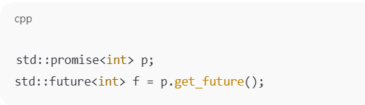

Then in another thread:
- The producer uses p.set_value(...).
- The consumer uses f.get() (which blocks until the value is available).
🛠 Where It's Used:
- Async function results (std::async)
- Thread result passing
- Task management systems
- Avoiding polling and busy-waiting
- Event signaling in multithreaded applications
🧪 Example: Simple Thread Result Passing
